Date: 06/04/26
📊 Final Count:
🟢 Bullish | 65
🔴 Bearish | 70
Total | 135

🟢 BULLISH TRADES --- 65
1 | ONGC26AprFUT
2 | BSE26AprFUT
3 | SAIL26AprFUT
4 | AMBUJACEM26AprFUT
5 | CGPOWER26AprFUT
6 | LICHSGFIN26AprFUT
7 | ANGELONE26AprFUT
8 | AUROPHARMA26AprFUT
9 | BDL26AprFUT
10 | CAMS26AprFUT
11 | NAUKRI26AprFUT
12 | KPITTECH26AprFUT
13 | KFINTECH26AprFUT
14 | NBCC26AprFUT
15 | PAGEIND26AprFUT
16 | RECLTD26AprFUT
17 | VBL26AprFUT
18 | MARUTI26AprFUT
19 | RVNL26AprFUT
20 | COFORGE26AprFUT
21 | CUMMINSIND26AprFUT
22 | POWERINDIA26AprFUT
23 | FEDERALBNK26AprFUT
24 | PETRONET26AprFUT
25 | SOLARINDS26AprFUT
26 | ABB26AprFUT
27 | BEL26AprFUT
28 | NATIONALUM26AprFUT
29 | OIL26AprFUT
30 | OFSS26AprFUT
31 | HINDZINC26AprFUT
32 | HUDCO26AprFUT
33 | INDUSTOWER26AprFUT
34 | JSWENERGY26AprFUT
35 | KEI26AprFUT
36 | LTM26AprFUT
37 | LODHA26AprFUT
38 | TATATECH26AprFUT
39 | PHOENIXLTD26AprFUT
40 | GAIL26AprFUT
41 | MPHASIS26AprFUT
42 | PFC26AprFUT
43 | TECHM26AprFUT
44 | VEDL26AprFUT
45 | HCLTECH26AprFUT
46 | INDIGO26AprFUT
47 | TCS26AprFUT
48 | UNIONBANK26AprFUT
49 | DELHIVERY26AprFUT
50 | NYKAA26AprFUT
51 | GMRAIRPORT26AprFUT
52 | HDFCAMC26AprFUT
53 | INFY26AprFUT
54 | TATAELXSI26AprFUT
55 | PIIND26AprFUT
56 | SAMMAANCAP26AprFUT
57 | PERSISTENT26AprFUT
58 | COALINDIA26AprFUT
59 | BAJAJ-AUTO26AprFUT
60 | BANKINDIA26AprFUT
61 | EXIDEIND26AprFUT
62 | GODREJPROP26AprFUT
63 | NUVAMA26AprFUT
64 | OBEROIRLTY26AprFUT
65 | TIINDIA26AprFUT
🔴 BEARISH TRADES --- 70
1 | 360ONE26AprFUT
2 | APLAPOLLO26AprFUT
3 | ALKEM26AprFUT
4 | AMBER26AprFUT
5 | APOLLOHOSP26AprFUT
6 | ASHOKLEY26AprFUT
7 | ASIANPAINT26AprFUT
8 | ASTRAL26AprFUT
9 | BAJAJFINSV26AprFUT
10 | BHEL26AprFUT
11 | BPCL26AprFUT
12 | BHARTIARTL26AprFUT
13 | BIOCON26AprFUT
14 | BLUESTARCO26AprFUT
15 | CHOLAFIN26AprFUT
16 | CIPLA26AprFUT
17 | COLPAL26AprFUT
18 | CROMPTON26AprFUT
19 | DIVISLAB26AprFUT
20 | DIXON26AprFUT
21 | ICICIBANK26AprFUT
22 | ICICIGI26AprFUT
23 | ICICIPRULI26AprFUT
24 | IDFCFIRSTB26AprFUT
25 | INDUSINDBK26AprFUT
26 | JIOFIN26AprFUT
27 | KAYNES26AprFUT
28 | KOTAKBANK26AprFUT
29 | LICI26AprFUT
30 | LUPIN26AprFUT
31 | MFSL26AprFUT
32 | MAXHEALTH26AprFUT
33 | POLICYBZR26AprFUT
34 | PGEL26AprFUT
35 | RELIANCE26AprFUT
36 | SBICARD26AprFUT
37 | SBILIFE26AprFUT
38 | SRF26AprFUT
39 | SUNPHARMA26AprFUT
40 | VOLTAS26AprFUT
41 | ZYDUSLIFE26AprFUT
42 | BRITANNIA26AprFUT
43 | DRREDDY26AprFUT
44 | ETERNAL26AprFUT
45 | EICHERMOT26AprFUT
46 | FORTIS26AprFUT
47 | GLENMARK26AprFUT
48 | GODREJCP26AprFUT
49 | GRASIM26AprFUT
50 | HDFCLIFE26AprFUT
51 | HAVELLS26AprFUT
52 | HINDPETRO26AprFUT
53 | HINDUNILVR26AprFUT
54 | NTPC26AprFUT
55 | POWERGRID26AprFUT
56 | MOTHERSON26AprFUT
57 | SUPREMEIND26AprFUT
58 | INDHOTEL26AprFUT
59 | TORNTPHARM26AprFUT
60 | UPL26AprFUT
61 | UNITDSPR26AprFUT
62 | IDEA26AprFUT
63 | BHARATFORG26AprFUT
64 | UNOMINDA26AprFUT
65 | HEROMOTOCO26AprFUT
66 | ULTRACEMCO26AprFUT
67 | PIDILITIND26AprFUT
68 | PPLPHARMA26AprFUT
69 | ITC26AprFUT
70 | M&M26AprFUT

Trade Taken
🟢 BULLISH SIGNAL --- BSE26AprFUT

Nifty Bias : 🟢 LONG — Aligned ✅
Crossover : 2026-04-02 14:00 (4 days ago)
Pullback : 2026-04-06 09:15
Low ₹2832 ≤ EMA9(Low) ₹2837.25
High ₹2897.1 (breakout level)
Confirm : 2026-04-06 09:30 (+1 candle)
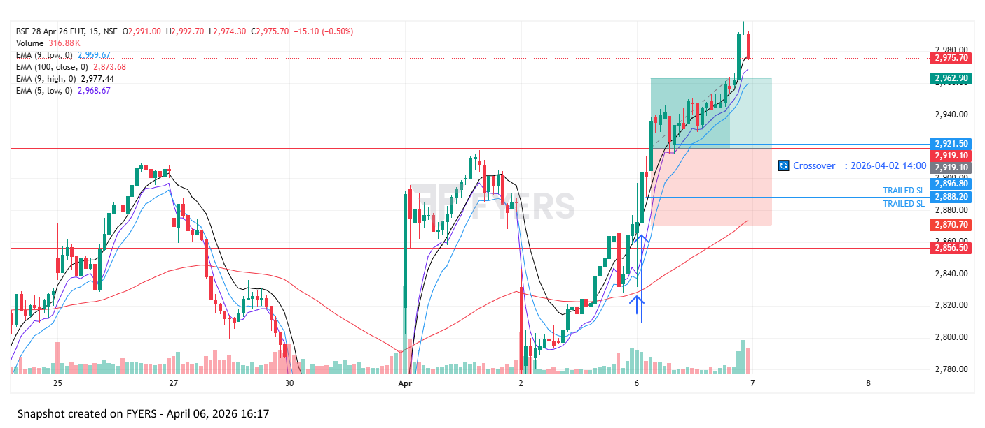
🟢 BULLISH SIGNAL --- CAMS26AprFUT

Nifty Bias : ⚠️ CHOPPY — Choppy ⚠️
Crossover : 2026-04-02 14:15 (4 days ago)
Pullback : 2026-04-06 09:45
Low ₹648.55 ≤ EMA9(Low) ₹648.91
High ₹652.7 (breakout level)
Confirm : 2026-04-06 10:00 (+1 candle)
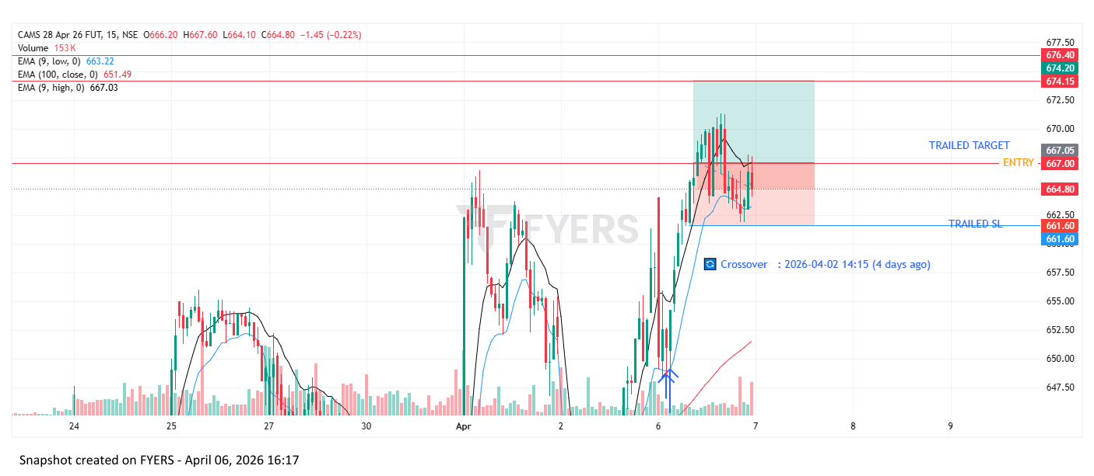
🟢 BULLISH SIGNAL --- PAGEIND26AprFUT

Nifty Bias : ⚠️ CHOPPY — Choppy ⚠️
Crossover : 2026-04-01 10:15 (5 days ago)
Pullback : 2026-04-06 09:15
Low ₹33720 ≤ EMA9(Low) ₹33871.12
High ₹34430 (breakout level)
Confirm : 2026-04-06 10:00 (+3 candle)
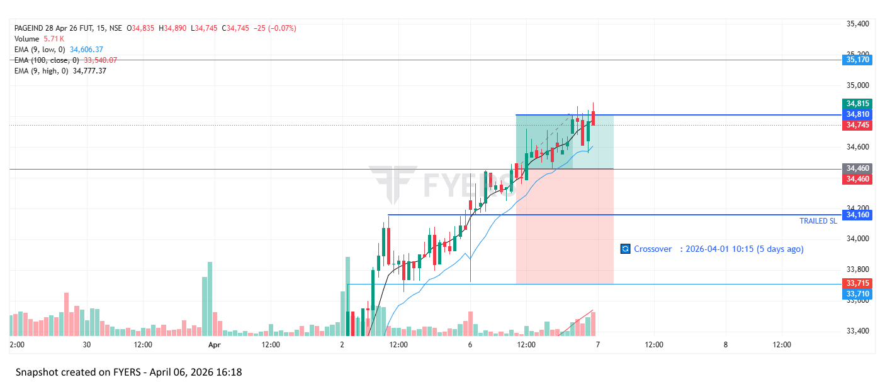
🟢 BULLISH SIGNAL --- ABB26AprFUT

Nifty Bias : 🟢 LONG — Aligned ✅
Crossover : 2026-04-02 14:15 (4 days ago)
Pullback : 2026-04-06 11:15
Low ₹6140.5 ≤ EMA9(Low) ₹6155.99
High ₹6166 (breakout level)
Confirm : 2026-04-06 11:30 (+1 candle)
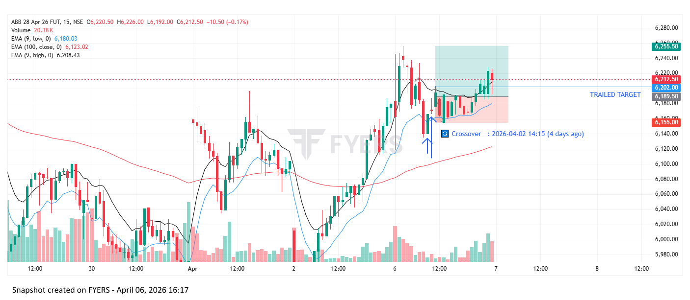
🟢 BULLISH SIGNAL --- LODHA26AprFUT

Nifty Bias : 🟢 LONG — Aligned ✅
Crossover : 2026-04-06 10:15 (2 hours ago)
Pullback : 2026-04-06 11:30
Low ₹696.35 ≤ EMA9(Low) ₹697.29
High ₹698.6 (breakout level)
Confirm : 2026-04-06 11:45 (+1 candle)
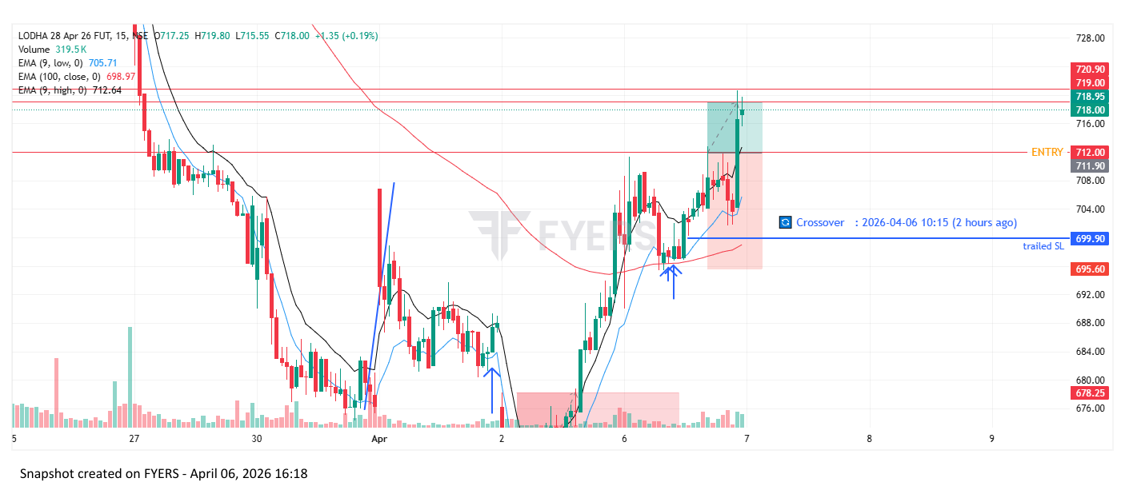
🟢 BULLISH SIGNAL --- GMRAIRPORT26AprFUT

Nifty Bias : 🟢 LONG — Aligned ✅
Crossover : 2026-04-06 11:30 (2 hours ago)
Pullback : 2026-04-06 12:15
Low ₹88.55 ≤ EMA9(Low) ₹88.57
High ₹89.1 (breakout level)
Confirm : 2026-04-06 12:45 (+2 candle)
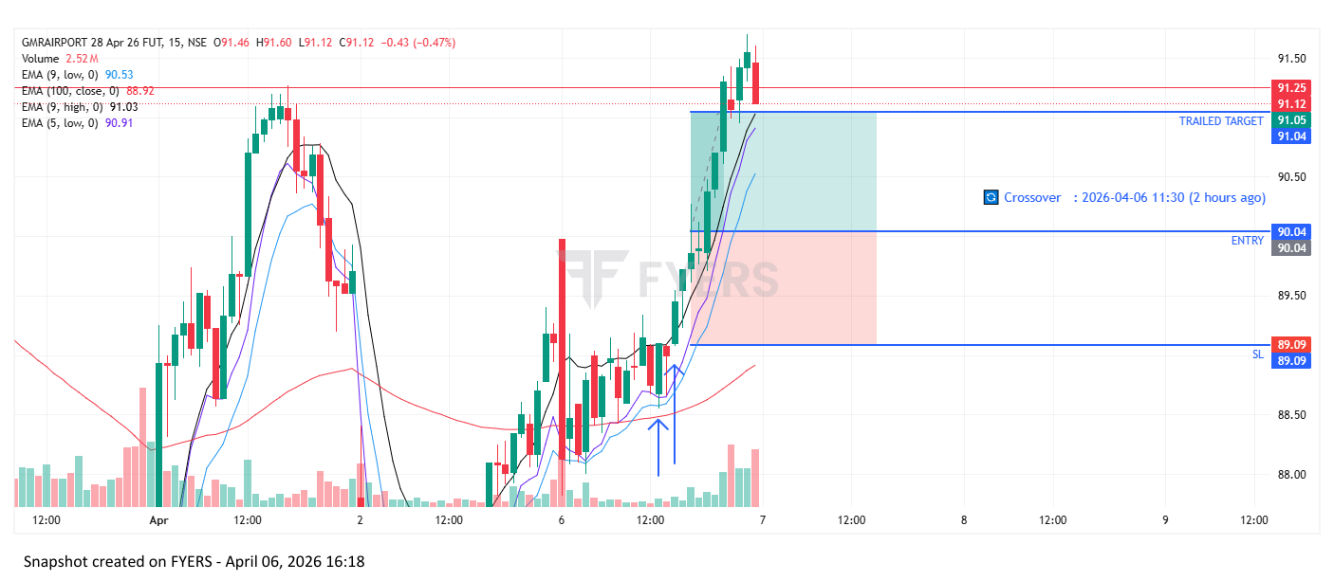

Trade Not Taken
🔴 BEARISH SIGNAL --- 360ONE26AprFUT

Nifty Bias : 🟢 LONG — Counter Trend ⚠️
Crossover : 2026-03-25 14:15 (12 days ago)
Pullback : 2026-04-02 15:00
High ₹943 ≥ EMA9(High) ₹939.59
Low ₹936.65 (breakdown level)
Confirm : 2026-04-06 09:15 (+2 candle)
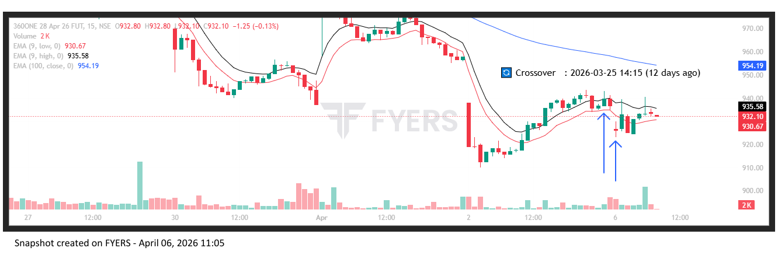
🔴 BEARISH SIGNAL --- APLAPOLLO26AprFUT

Nifty Bias : 🟢 LONG — Counter Trend ⚠️
Crossover : 2026-04-01 14:30 (5 days ago)
Pullback : 2026-04-02 15:00
High ₹1914.9 ≥ EMA9(High) ₹1899.1
Low ₹1893.8 (breakdown level)
Confirm : 2026-04-06 09:15 (+2 candle)
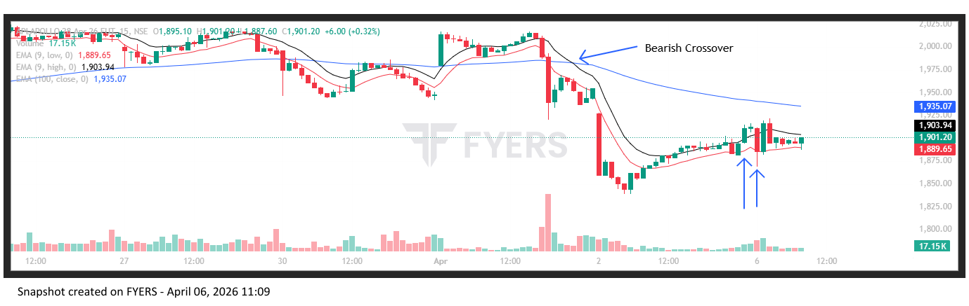
🔴 BEARISH SIGNAL --- ALKEM26AprFUT

Nifty Bias : 🟢 LONG — Counter Trend ⚠️
Crossover : 2026-04-01 13:15 (5 days ago)
Pullback : 2026-04-02 14:45
High ₹5254.5 ≥ EMA9(High) ₹5240.64
Low ₹5241 (breakdown level)
Confirm : 2026-04-06 09:15 (+3 candle)
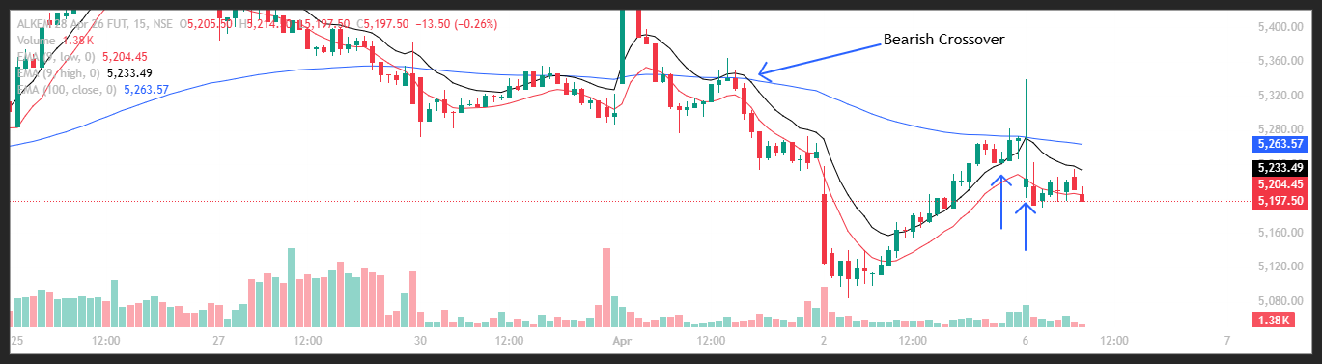
🔴 BEARISH SIGNAL --- AMBER26AprFUT

Nifty Bias : 🟢 LONG — Counter Trend ⚠️
Crossover : 2026-04-02 09:30 (4 days ago)
Pullback : 2026-04-02 15:00
High ₹6225 ≥ EMA9(High) ₹6202.93
Low ₹6138.5 (breakdown level)
Confirm : 2026-04-06 09:15 (+2 candle)
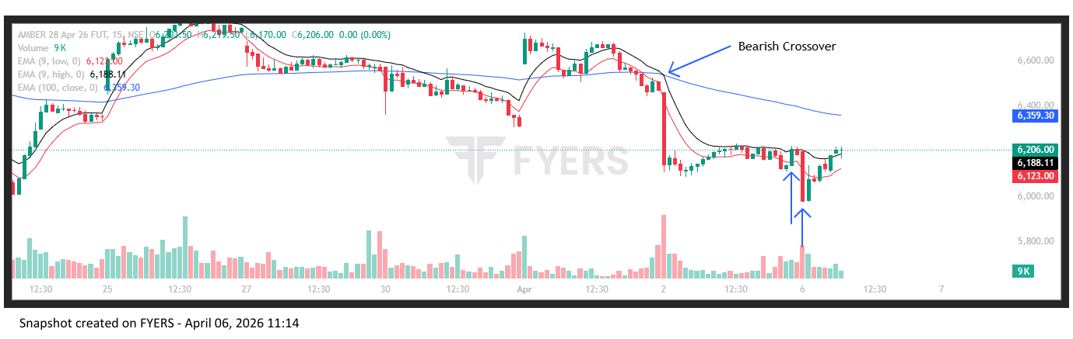
🔴 BEARISH SIGNAL --- APOLLOHOSP26AprFUT

Nifty Bias : 🟢 LONG — Counter Trend ⚠️
Crossover : 2026-04-01 10:30 (5 days ago)
Pullback : 2026-04-02 15:00
High ₹7379 ≥ EMA9(High) ₹7357.01
Low ₹7328 (breakdown level)
Confirm : 2026-04-06 09:15 (+2 candle)
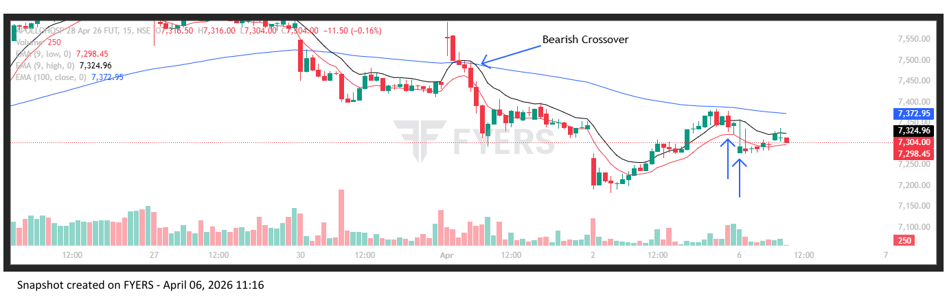
🔴 BEARISH SIGNAL --- ASHOKLEY26AprFUT

Nifty Bias : 🟢 LONG — Counter Trend ⚠️
Crossover : 2026-03-27 10:15 (10 days ago)
Pullback : 2026-04-02 15:15
High ₹148.94 ≥ EMA9(High) ₹148.08
Low ₹148.18 (breakdown level)
Confirm : 2026-04-06 09:15 (+1 candle)
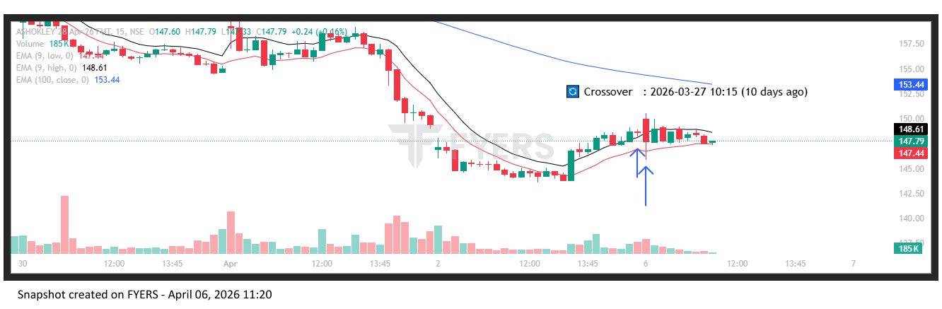
🔴 BEARISH SIGNAL --- ASIANPAINT26AprFUT

Nifty Bias : 🟢 LONG — Counter Trend ⚠️
Crossover : 2026-04-02 09:30 (4 days ago)
Pullback : 2026-04-02 14:45
High ₹2178.1 ≥ EMA9(High) ₹2176.95
Low ₹2170.3 (breakdown level)
Confirm : 2026-04-06 09:15 (+3 candle)
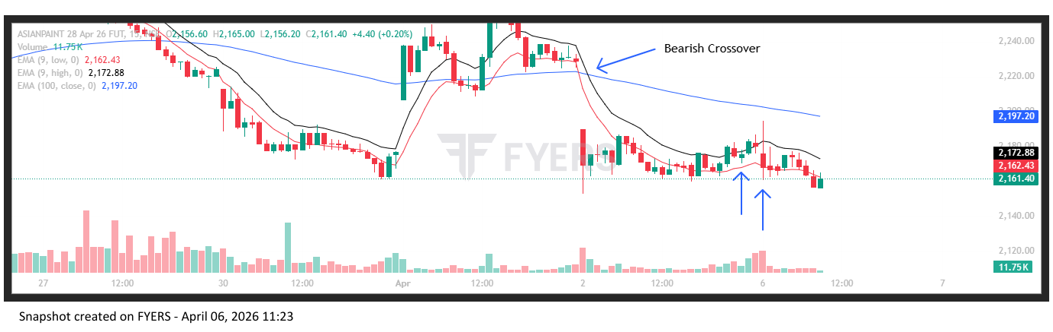
🔴 BEARISH SIGNAL --- ASTRAL26AprFUT

Nifty Bias : 🟢 LONG — Counter Trend ⚠️
Crossover : 2026-04-01 15:00 (5 days ago)
Pullback : 2026-04-02 14:45
High ₹1515.8 ≥ EMA9(High) ₹1511.04
Low ₹1505 (breakdown level)
Confirm : 2026-04-06 09:15 (+3 candle)
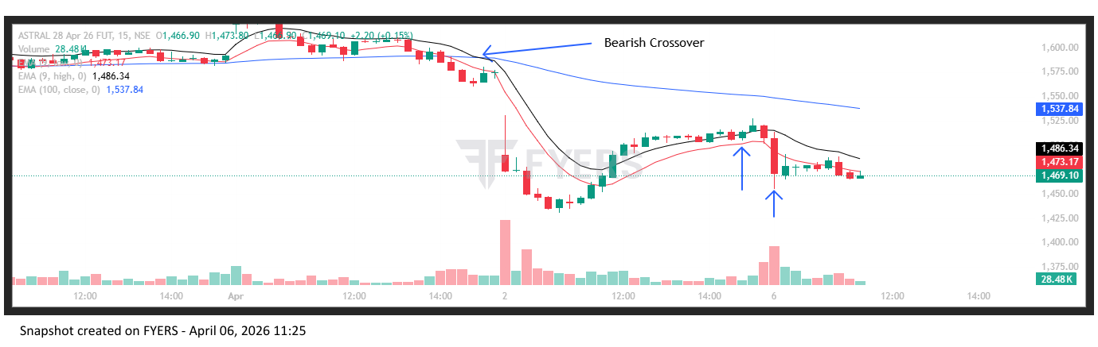
🔴 BEARISH SIGNAL --- BAJAJFINSV26AprFUT

Nifty Bias : 🟢 LONG — Counter Trend ⚠️
Crossover : 2026-03-27 10:45 (10 days ago)
Pullback : 2026-04-02 15:00
High ₹1648 ≥ EMA9(High) ₹1640.05
Low ₹1636.2 (breakdown level)
Confirm : 2026-04-06 09:15 (+2 candle)
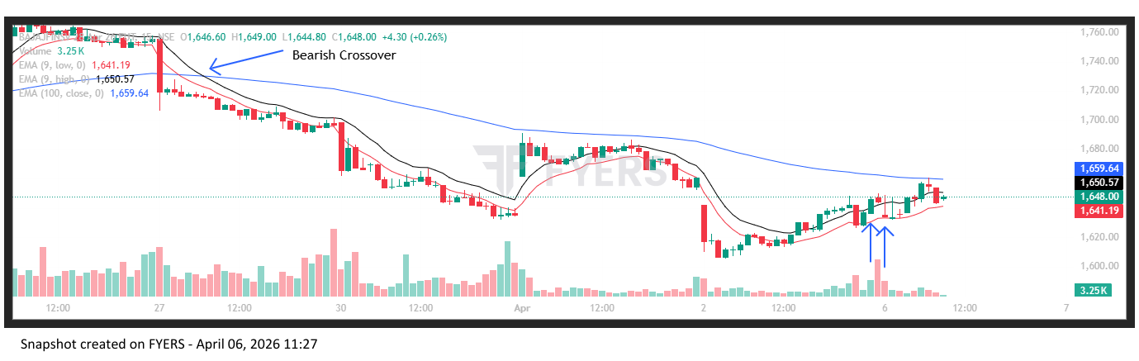
🔴 BEARISH SIGNAL --- BHEL26AprFUT

Nifty Bias : 🟢 LONG — Counter Trend ⚠️
Crossover : 2026-04-01 14:45 (5 days ago)
Pullback : 2026-04-02 14:45
High ₹248.55 ≥ EMA9(High) ₹248.47
Low ₹246.9 (breakdown level)
Confirm : 2026-04-06 09:15 (+3 candle)
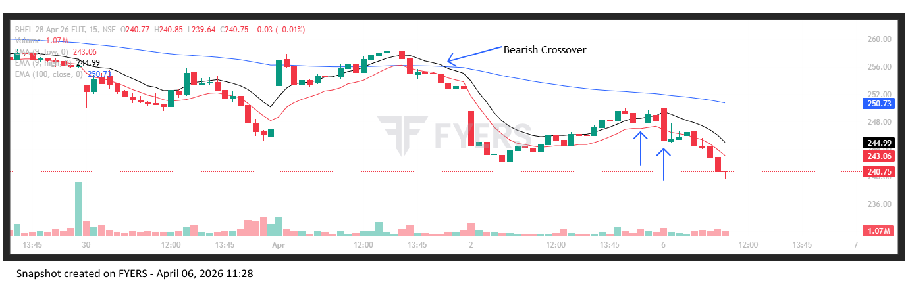
🔴 BEARISH SIGNAL --- BPCL26AprFUT

Nifty Bias : 🟢 LONG — Counter Trend ⚠️
Crossover : 2026-04-01 15:15 (5 days ago)
Pullback : 2026-04-02 14:45
High ₹277.65 ≥ EMA9(High) ₹276.69
Low ₹276.35 (breakdown level)
Confirm : 2026-04-06 09:15 (+3 candle)
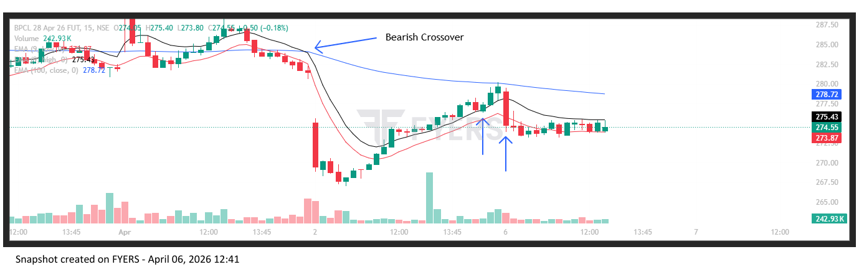
🔴 BEARISH SIGNAL --- BHARTIARTL26AprFUT

Nifty Bias : 🟢 LONG — Counter Trend ⚠️
Crossover : 2026-03-30 10:00 (7 days ago)
Pullback : 2026-04-02 14:45
High ₹1796.8 ≥ EMA9(High) ₹1783.32
Low ₹1785.4 (breakdown level)
Confirm : 2026-04-06 09:15 (+3 candle)
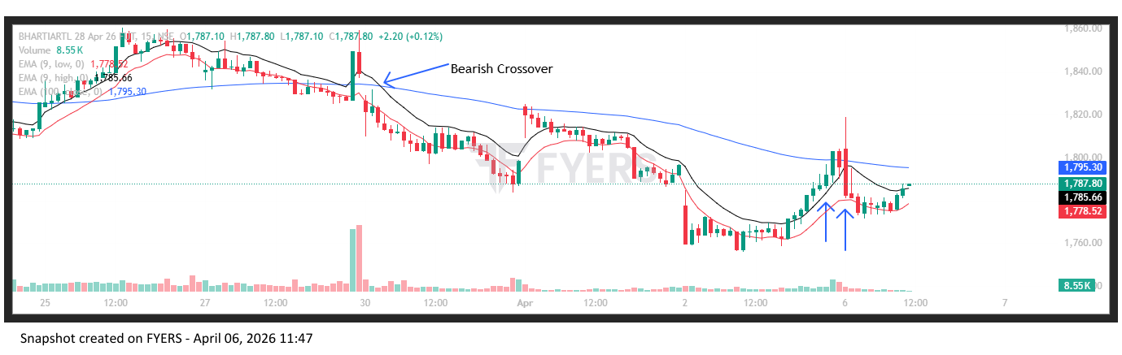
🔴 BEARISH SIGNAL --- BIOCON26AprFUT

Nifty Bias : 🟢 LONG — Counter Trend ⚠️
Crossover : 2026-04-01 14:30 (5 days ago)
Pullback : 2026-04-02 14:45
High ₹353.95 ≥ EMA9(High) ₹353.49
Low ₹352.05 (breakdown level)
Confirm : 2026-04-06 09:15 (+3 candle)
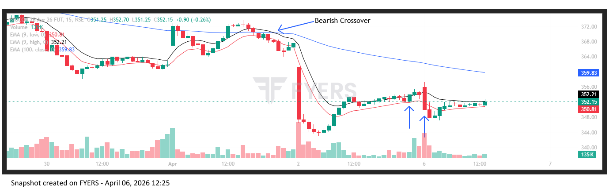
🔴 BEARISH SIGNAL --- BLUESTARCO26AprFUT

Nifty Bias : 🟢 LONG — Counter Trend ⚠️
Crossover : 2026-03-27 11:00 (10 days ago)
Pullback : 2026-04-02 15:00
High ₹1539.6 ≥ EMA9(High) ₹1527.5
Low ₹1521.7 (breakdown level)
Confirm : 2026-04-06 09:15 (+2 candle)
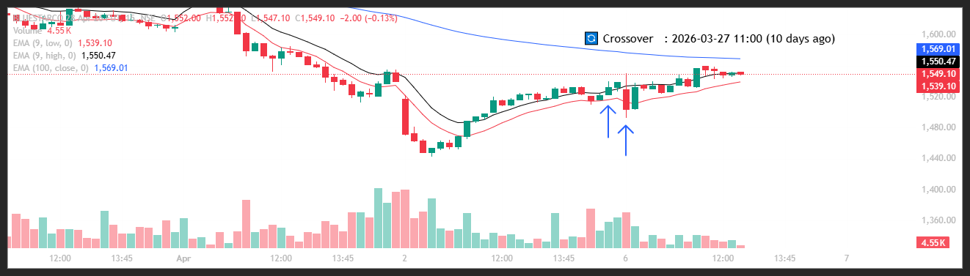
🔴 BEARISH SIGNAL --- CHOLAFIN26AprFUT

Nifty Bias : 🟢 LONG — Counter Trend ⚠️
Crossover : 2026-03-27 10:30 (10 days ago)
Pullback : 2026-04-02 15:00
High ₹1367.4 ≥ EMA9(High) ₹1354.18
Low ₹1353.8 (breakdown level)
Confirm : 2026-04-06 09:15 (+2 candle)
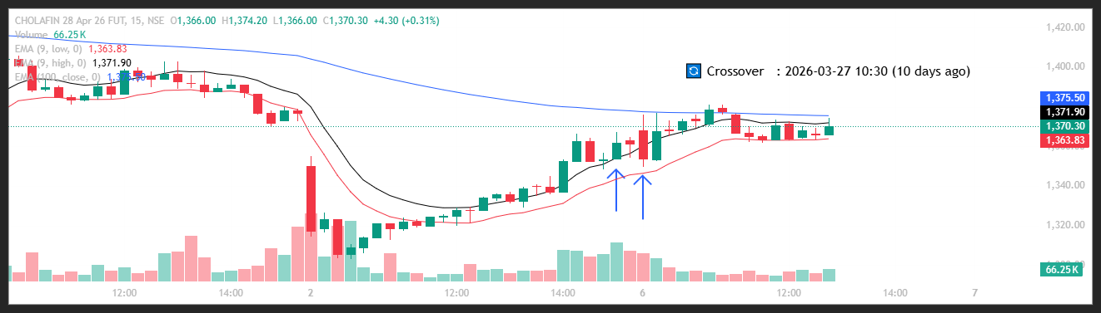
🔴 BEARISH SIGNAL --- CIPLA26AprFUT

Nifty Bias : 🟢 LONG — Counter Trend ⚠️
Crossover : 2026-03-27 13:00 (10 days ago)
Pullback : 2026-04-02 14:45
High ₹1201.7 ≥ EMA9(High) ₹1198.64
Low ₹1195.9 (breakdown level)
Confirm : 2026-04-06 09:15 (+3 candle)
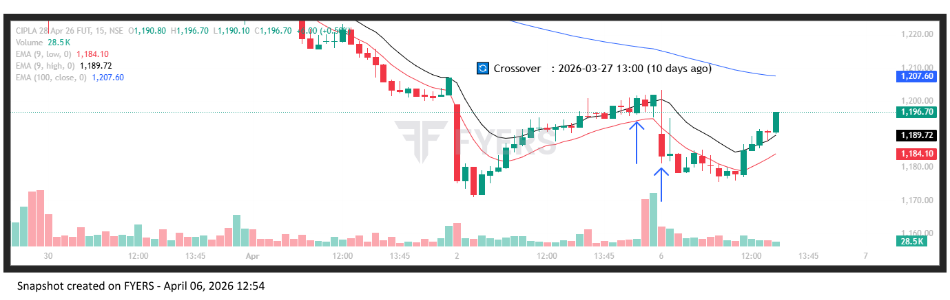
🔴 BEARISH SIGNAL --- COLPAL26AprFUT

Nifty Bias : 🟢 LONG — Counter Trend ⚠️
Crossover : 2026-03-27 12:30 (10 days ago)
Pullback : 2026-04-02 15:00
High ₹1837.9 ≥ EMA9(High) ₹1830.78
Low ₹1830.3 (breakdown level)
Confirm : 2026-04-06 09:15 (+2 candle)
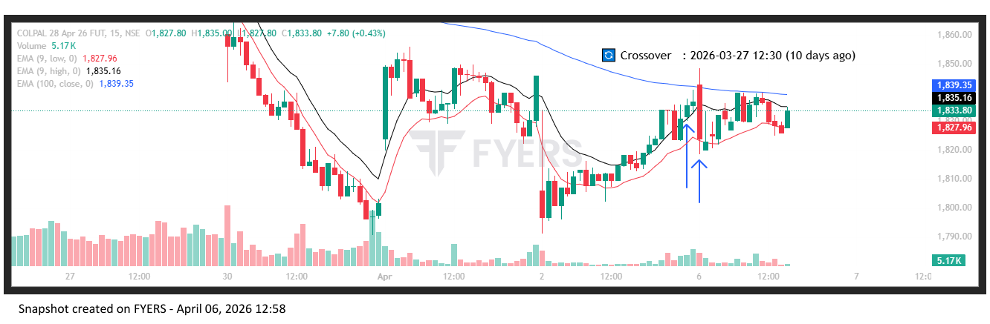
🔴 BEARISH SIGNAL --- CROMPTON26AprFUT

Nifty Bias : 🟢 LONG — Counter Trend ⚠️
Crossover : 2026-03-27 10:15 (10 days ago)
Pullback : 2026-04-02 14:45
High ₹231 ≥ EMA9(High) ₹230.74
Low ₹229.9 (breakdown level)
Confirm : 2026-04-06 09:15 (+3 candle)
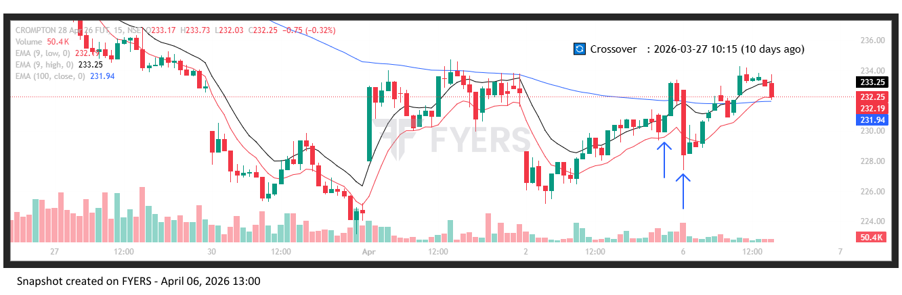
🔴 BEARISH SIGNAL --- DIVISLAB26AprFUT

Nifty Bias : 🟢 LONG — Counter Trend ⚠️
Crossover : 2026-04-01 13:15 (5 days ago)
Pullback : 2026-04-02 14:45
High ₹5878 ≥ EMA9(High) ₹5869.44
Low ₹5852.5 (breakdown level)
Confirm : 2026-04-06 09:15 (+3 candle)
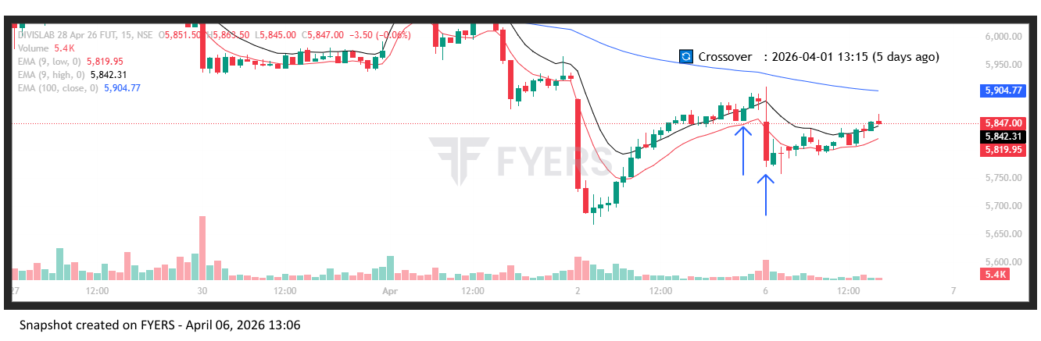
🔴 BEARISH SIGNAL --- DIXON26AprFUT

Nifty Bias : 🟢 LONG — Counter Trend ⚠️
Crossover : 2026-04-02 13:30 (4 days ago)
Pullback : 2026-04-02 15:00
High ₹9848 ≥ EMA9(High) ₹9802.6
Low ₹9664 (breakdown level)
Confirm : 2026-04-06 09:15 (+2 candle)
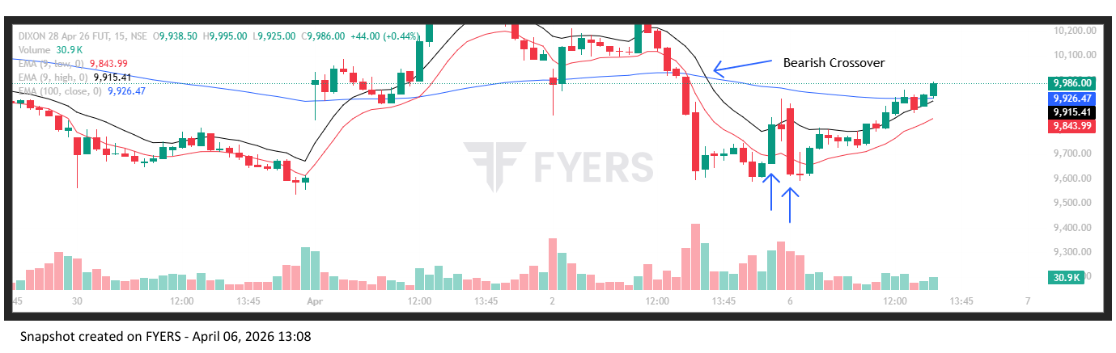
🔴 BEARISH SIGNAL --- ICICIBANK26AprFUT

Nifty Bias : 🟢 LONG — Counter Trend ⚠️
Crossover : 2026-03-27 11:15 (10 days ago)
Pullback : 2026-04-02 14:45
High ₹1213.7 ≥ EMA9(High) ₹1210.53
Low ₹1208 (breakdown level)
Confirm : 2026-04-06 09:15 (+3 candle)
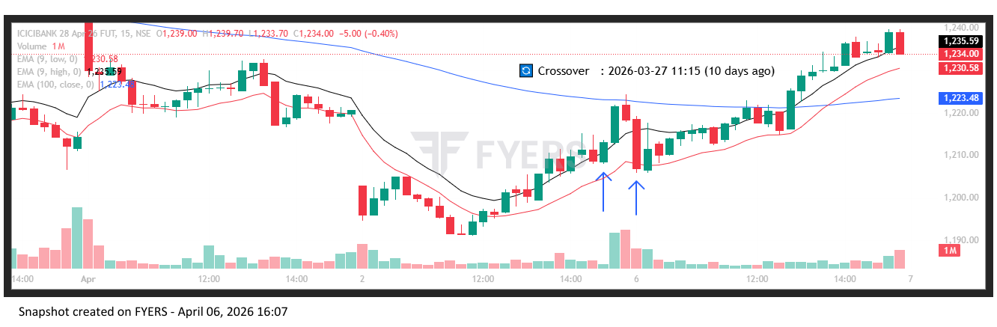
🔴 BEARISH SIGNAL --- ICICIGI26AprFUT

Nifty Bias : 🟢 LONG — Counter Trend ⚠️
Crossover : 2026-03-27 11:00 (10 days ago)
Pullback : 2026-04-02 15:00
High ₹1697 ≥ EMA9(High) ₹1679.64
Low ₹1686.1 (breakdown level)
Confirm : 2026-04-06 09:15 (+2 candle)
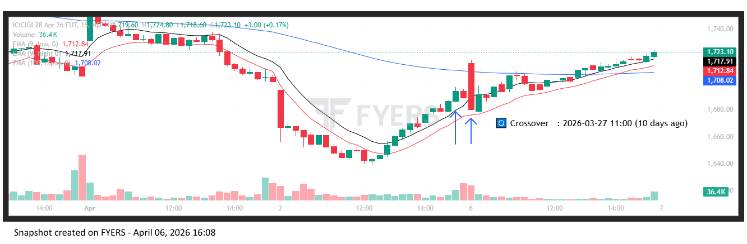
🔴 BEARISH SIGNAL --- ICICIPRULI26AprFUT

Nifty Bias : 🟢 LONG — Counter Trend ⚠️
Crossover : 2026-03-25 13:15 (12 days ago)
Pullback : 2026-04-02 15:00
High ₹508.4 ≥ EMA9(High) ₹504.08
Low ₹504.7 (breakdown level)
Confirm : 2026-04-06 09:15 (+2 candle)
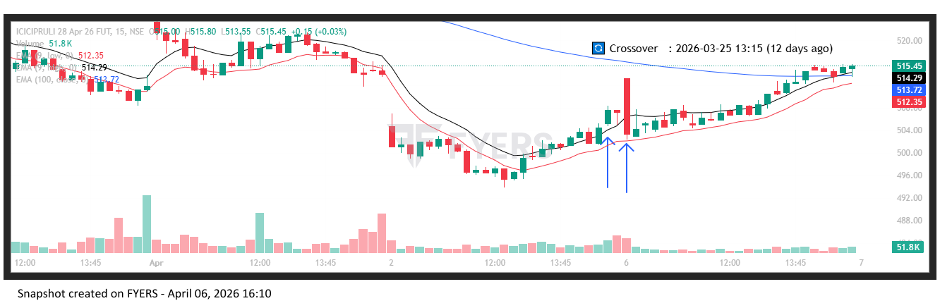
🔴 BEARISH SIGNAL --- IDFCFIRSTB26AprFUT

Nifty Bias : 🟢 LONG — Counter Trend ⚠️
Crossover : 2026-03-27 10:45 (10 days ago)
Pullback : 2026-04-02 15:00
High ₹60.85 ≥ EMA9(High) ₹60
Low ₹59.98 (breakdown level)
Confirm : 2026-04-06 09:15 (+2 candle)
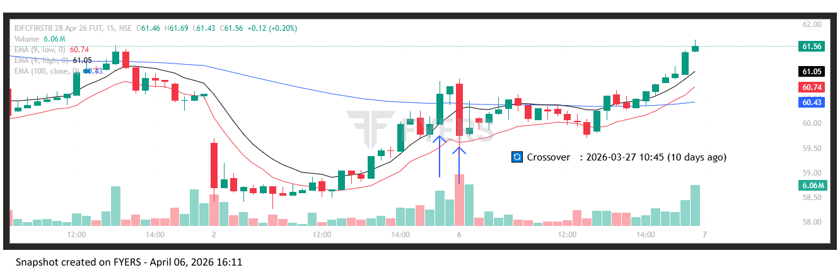
🔴 BEARISH SIGNAL --- INDUSINDBK26AprFUT

Nifty Bias : 🟢 LONG — Counter Trend ⚠️
Crossover : 2026-04-02 09:15 (4 days ago)
Pullback : 2026-04-02 14:45
High ₹776.1 ≥ EMA9(High) ₹772.63
Low ₹771 (breakdown level)
Confirm : 2026-04-06 09:15 (+3 candle)
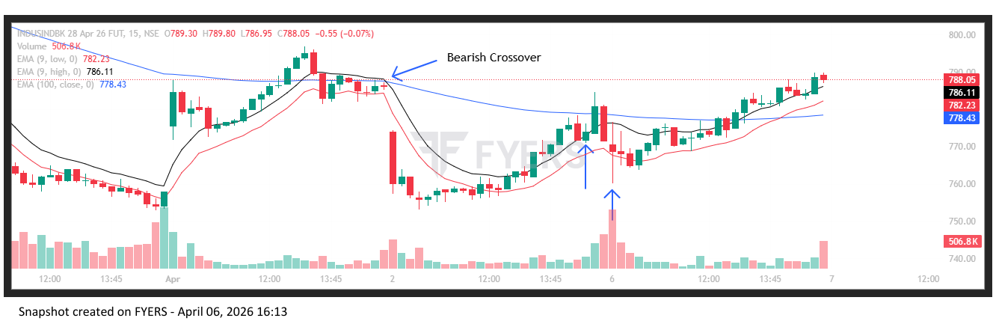
🔴 BEARISH SIGNAL --- JIOFIN26AprFUT

Nifty Bias : 🟢 LONG — Counter Trend ⚠️
Crossover : 2026-04-02 09:15 (4 days ago)
Pullback : 2026-04-02 14:45
High ₹229.35 ≥ EMA9(High) ₹228.49
Low ₹228.08 (breakdown level)
Confirm : 2026-04-06 09:15 (+3 candle)
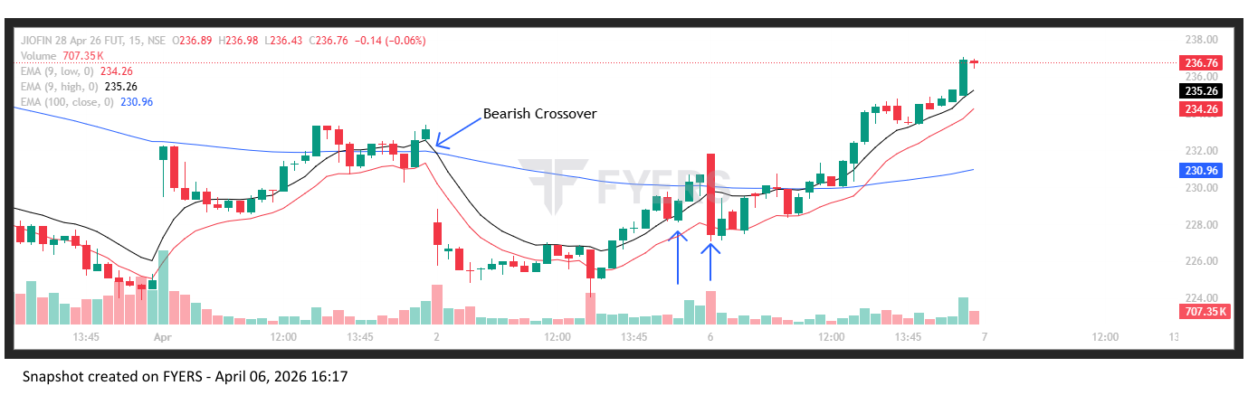
🔴 BEARISH SIGNAL --- KAYNES26AprFUT

Nifty Bias : 🟢 LONG — Counter Trend ⚠️
Crossover : 2026-04-01 14:45 (5 days ago)
Pullback : 2026-04-02 15:00
High ₹3521 ≥ EMA9(High) ₹3486.95
Low ₹3480.9 (breakdown level)
Confirm : 2026-04-06 09:15 (+2 candle)
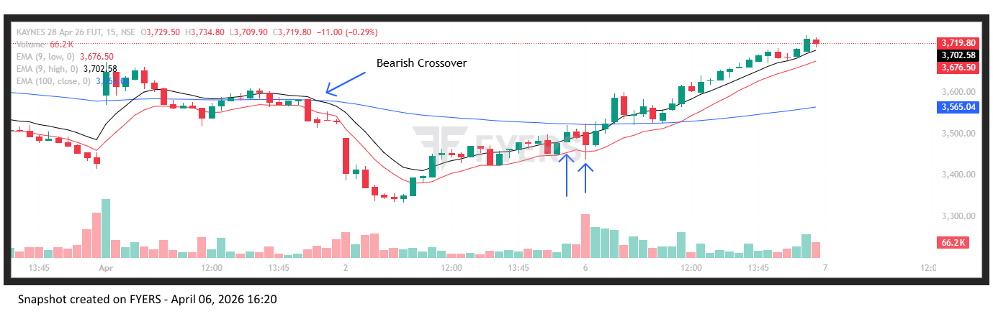
🔴 BEARISH SIGNAL --- KOTAKBANK26AprFUT

Nifty Bias : 🟢 LONG — Counter Trend ⚠️
Crossover : 2026-03-27 10:00 (10 days ago)
Pullback : 2026-04-02 14:45
High ₹357.2 ≥ EMA9(High) ₹356.04
Low ₹355.4 (breakdown level)
Confirm : 2026-04-06 09:15 (+3 candle)
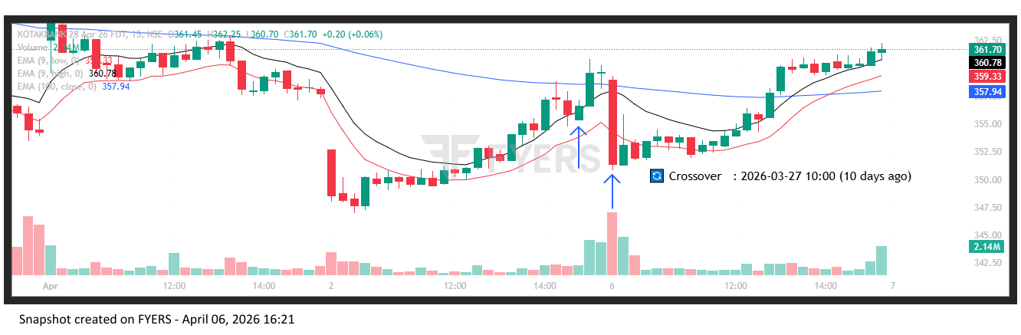
🔴 BEARISH SIGNAL --- LICI26AprFUT

Nifty Bias : 🟢 LONG — Counter Trend ⚠️
Crossover : 2026-04-01 14:00 (5 days ago)
Pullback : 2026-04-02 15:15
High ₹738.8 ≥ EMA9(High) ₹734.44
Low ₹736.8 (breakdown level)
Confirm : 2026-04-06 09:15 (+1 candle)
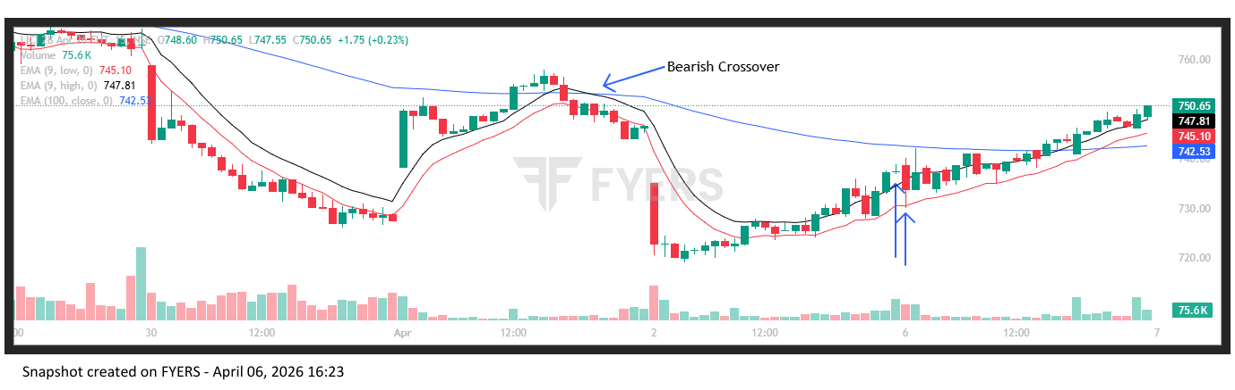
🔴 BEARISH SIGNAL --- LUPIN26AprFUT

Nifty Bias : 🟢 LONG — Counter Trend ⚠️
Crossover : 2026-04-01 11:00 (5 days ago)
Pullback : 2026-04-02 14:45
High ₹2264.5 ≥ EMA9(High) ₹2261.2
Low ₹2257 (breakdown level)
Confirm : 2026-04-06 09:15 (+3 candle)
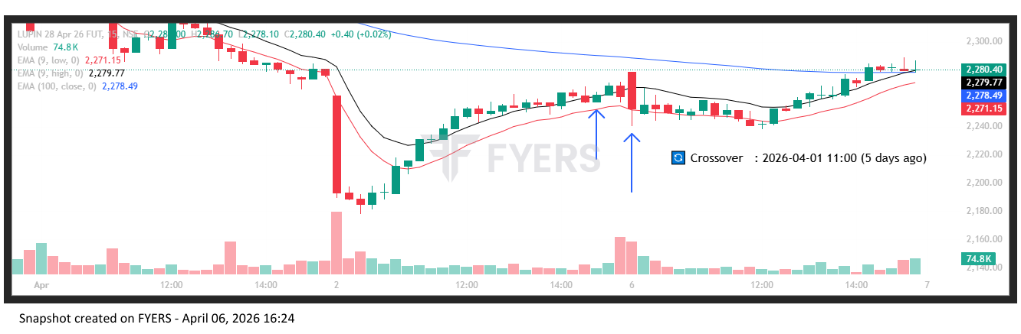
🔴 BEARISH SIGNAL --- MFSL26AprFUT

Nifty Bias : 🟢 LONG — Counter Trend ⚠️
Crossover : 2026-03-25 15:00 (12 days ago)
Pullback : 2026-04-02 14:45
High ₹1475 ≥ EMA9(High) ₹1471.58
Low ₹1470.4 (breakdown level)
Confirm : 2026-04-06 09:15 (+3 candle)

🔴 BEARISH SIGNAL --- MAXHEALTH26AprFUT

Nifty Bias : 🟢 LONG — Counter Trend ⚠️
Crossover : 2026-04-01 13:30 (5 days ago)
Pullback : 2026-04-02 15:00
High ₹952.1 ≥ EMA9(High) ₹951.85
Low ₹946.6 (breakdown level)
Confirm : 2026-04-06 09:15 (+2 candle)

🟢 BULLISH SIGNAL --- ONGC26AprFUT

Nifty Bias : 🟢 LONG — Aligned ✅
Crossover : 2026-03-25 10:15 (12 days ago)
Pullback : 2026-04-02 15:00
Low ₹286.3 ≤ EMA9(Low) ₹286.44
High ₹288.4 (breakout level)
Confirm : 2026-04-06 09:15 (+2 candle)

🔴 BEARISH SIGNAL --- POLICYBZR26AprFUT

Nifty Bias : 🟢 LONG — Counter Trend ⚠️
Crossover : 2026-04-01 14:45 (5 days ago)
Pullback : 2026-04-02 15:00
High ₹1438 ≥ EMA9(High) ₹1428.6
Low ₹1423.3 (breakdown level)
Confirm : 2026-04-06 09:15 (+2 candle)

🔴 BEARISH SIGNAL --- PGEL26AprFUT

Nifty Bias : 🟢 LONG — Counter Trend ⚠️
Crossover : 2026-04-01 14:00 (5 days ago)
Pullback : 2026-04-02 15:00
High ₹439.35 ≥ EMA9(High) ₹437.26
Low ₹434.85 (breakdown level)
Confirm : 2026-04-06 09:15 (+2 candle)

🔴 BEARISH SIGNAL --- RELIANCE26AprFUT

Nifty Bias : 🟢 LONG — Counter Trend ⚠️
Crossover : 2026-03-27 09:30 (10 days ago)
Pullback : 2026-04-02 14:45
High ₹1358.8 ≥ EMA9(High) ₹1357.46
Low ₹1354.5 (breakdown level)
Confirm : 2026-04-06 09:15 (+3 candle)

🔴 BEARISH SIGNAL --- SBICARD26AprFUT

Nifty Bias : 🟢 LONG — Counter Trend ⚠️
Crossover : 2026-03-30 10:45 (7 days ago)
Pullback : 2026-04-02 15:00
High ₹624.75 ≥ EMA9(High) ₹622.31
Low ₹619.55 (breakdown level)
Confirm : 2026-04-06 09:15 (+2 candle)

🔴 BEARISH SIGNAL --- SBILIFE26AprFUT

Nifty Bias : 🟢 LONG — Counter Trend ⚠️
Crossover : 2026-03-25 13:00 (12 days ago)
Pullback : 2026-04-02 14:45
High ₹1780.5 ≥ EMA9(High) ₹1774.37
Low ₹1769.1 (breakdown level)
Confirm : 2026-04-06 09:15 (+3 candle)

🔴 BEARISH SIGNAL --- SRF26AprFUT

Nifty Bias : 🟢 LONG — Counter Trend ⚠️
Crossover : 2026-04-02 10:00 (4 days ago)
Pullback : 2026-04-02 15:00
High ₹2438 ≥ EMA9(High) ₹2433.14
Low ₹2418.8 (breakdown level)
Confirm : 2026-04-06 09:15 (+2 candle)

🔴 BEARISH SIGNAL --- SUNPHARMA26AprFUT

Nifty Bias : 🟢 LONG — Counter Trend ⚠️
Crossover : 2026-03-30 10:15 (7 days ago)
Pullback : 2026-04-02 14:45
High ₹1705 ≥ EMA9(High) ₹1701.07
Low ₹1693.5 (breakdown level)
Confirm : 2026-04-06 09:15 (+3 candle)

🔴 BEARISH SIGNAL --- VOLTAS26AprFUT

Nifty Bias : 🟢 LONG — Counter Trend ⚠️
Crossover : 2026-03-30 09:15 (7 days ago)
Pullback : 2026-04-02 15:00
High ₹1233.2 ≥ EMA9(High) ₹1223.77
Low ₹1219.7 (breakdown level)
Confirm : 2026-04-06 09:15 (+2 candle)

🔴 BEARISH SIGNAL --- ZYDUSLIFE26AprFUT

Nifty Bias : 🟢 LONG — Counter Trend ⚠️
Crossover : 2026-03-30 10:00 (7 days ago)
Pullback : 2026-04-02 14:45
High ₹864 ≥ EMA9(High) ₹862.25
Low ₹860.25 (breakdown level)
Confirm : 2026-04-06 09:15 (+3 candle)

🔴 BEARISH SIGNAL --- BRITANNIA26AprFUT

Nifty Bias : 🟢 LONG — Counter Trend ⚠️
Crossover : 2026-03-27 11:00 (10 days ago)
Pullback : 2026-04-02 15:00
High ₹5494.5 ≥ EMA9(High) ₹5467.42
Low ₹5456.5 (breakdown level)
Confirm : 2026-04-06 09:30 (+3 candle)

🔴 BEARISH SIGNAL --- DRREDDY26AprFUT

Nifty Bias : 🟢 LONG — Counter Trend ⚠️
Crossover : 2026-03-30 09:30 (7 days ago)
Pullback : 2026-04-02 15:00
High ₹1213.5 ≥ EMA9(High) ₹1211.29
Low ₹1206 (breakdown level)
Confirm : 2026-04-06 09:15 (+2 candle)

🔴 BEARISH SIGNAL --- ETERNAL26AprFUT

Nifty Bias : 🟢 LONG — Counter Trend ⚠️
Crossover : 2026-04-02 09:45 (4 days ago)
Pullback : 2026-04-02 15:00
High ₹232.9 ≥ EMA9(High) ₹230.67
Low ₹231.22 (breakdown level)
Confirm : 2026-04-06 09:15 (+2 candle)

🔴 BEARISH SIGNAL --- EICHERMOT26AprFUT

Nifty Bias : 🟢 LONG — Counter Trend ⚠️
Crossover : 2026-04-02 09:30 (4 days ago)
Pullback : 2026-04-02 15:15
High ₹6700 ≥ EMA9(High) ₹6695.97
Low ₹6677.5 (breakdown level)
Confirm : 2026-04-06 09:15 (+1 candle)

🔴 BEARISH SIGNAL --- FORTIS26AprFUT

Nifty Bias : 🟢 LONG — Counter Trend ⚠️
Crossover : 2026-03-27 15:15 (10 days ago)
Pullback : 2026-04-02 15:00
High ₹793.75 ≥ EMA9(High) ₹789.83
Low ₹787.3 (breakdown level)
Confirm : 2026-04-06 09:15 (+2 candle)

🔴 BEARISH SIGNAL --- GLENMARK26AprFUT

Nifty Bias : 🟢 LONG — Counter Trend ⚠️
Crossover : 2026-04-01 13:30 (5 days ago)
Pullback : 2026-04-02 14:45
High ₹2094 ≥ EMA9(High) ₹2081.55
Low ₹2081.2 (breakdown level)
Confirm : 2026-04-06 09:15 (+3 candle)

🔴 BEARISH SIGNAL --- GODREJCP26AprFUT

Nifty Bias : 🟢 LONG — Counter Trend ⚠️
Crossover : 2026-03-27 11:00 (10 days ago)
Pullback : 2026-04-02 15:00
High ₹1002.9 ≥ EMA9(High) ₹999.18
Low ₹998.55 (breakdown level)
Confirm : 2026-04-06 09:15 (+2 candle)

🔴 BEARISH SIGNAL --- GRASIM26AprFUT

Nifty Bias : 🟢 LONG — Counter Trend ⚠️
Crossover : 2026-04-01 14:45 (5 days ago)
Pullback : 2026-04-02 14:45
High ₹2568.4 ≥ EMA9(High) ₹2565.5
Low ₹2561.5 (breakdown level)
Confirm : 2026-04-06 09:15 (+3 candle)

🔴 BEARISH SIGNAL --- HDFCLIFE26AprFUT

Nifty Bias : 🟢 LONG — Counter Trend ⚠️
Crossover : 2026-03-27 09:30 (10 days ago)
Pullback : 2026-04-02 14:45
High ₹570 ≥ EMA9(High) ₹568.41
Low ₹567.8 (breakdown level)
Confirm : 2026-04-06 09:15 (+3 candle)

🔴 BEARISH SIGNAL --- HAVELLS26AprFUT

Nifty Bias : 🟢 LONG — Counter Trend ⚠️
Crossover : 2026-03-27 10:00 (10 days ago)
Pullback : 2026-04-02 14:45
High ₹1180.4 ≥ EMA9(High) ₹1177.8
Low ₹1174.2 (breakdown level)
Confirm : 2026-04-06 09:15 (+3 candle)

🔴 BEARISH SIGNAL --- HINDPETRO26AprFUT

Nifty Bias : 🟢 LONG — Counter Trend ⚠️
Crossover : 2026-04-02 09:15 (4 days ago)
Pullback : 2026-04-02 14:45
High ₹325.2 ≥ EMA9(High) ₹324.91
Low ₹323.1 (breakdown level)
Confirm : 2026-04-06 09:15 (+3 candle)

🔴 BEARISH SIGNAL --- HINDUNILVR26AprFUT

Nifty Bias : 🟢 LONG — Counter Trend ⚠️
Crossover : 2026-03-27 11:45 (10 days ago)
Pullback : 2026-04-02 15:00
High ₹2073.9 ≥ EMA9(High) ₹2066.74
Low ₹2068.3 (breakdown level)
Confirm : 2026-04-06 09:15 (+2 candle)

🔴 BEARISH SIGNAL --- NTPC26AprFUT

Nifty Bias : 🟢 LONG — Counter Trend ⚠️
Crossover : 2026-03-30 09:30 (7 days ago)
Pullback : 2026-04-02 15:00
High ₹362.6 ≥ EMA9(High) ₹360.43
Low ₹359.7 (breakdown level)
Confirm : 2026-04-06 09:30 (+3 candle)

🔴 BEARISH SIGNAL --- POWERGRID26AprFUT

Nifty Bias : 🟢 LONG — Counter Trend ⚠️
Crossover : 2026-04-01 11:00 (5 days ago)
Pullback : 2026-04-06 09:15
High ₹295.65 ≥ EMA9(High) ₹291.72
Low ₹292.6 (breakdown level)
Confirm : 2026-04-06 09:30 (+1 candle)

🔴 BEARISH SIGNAL --- MOTHERSON26AprFUT

Nifty Bias : 🟢 LONG — Counter Trend ⚠️
Crossover : 2026-04-01 13:45 (5 days ago)
Pullback : 2026-04-02 15:15
High ₹107.75 ≥ EMA9(High) ₹107.35
Low ₹107.28 (breakdown level)
Confirm : 2026-04-06 09:30 (+2 candle)

🟢 BULLISH SIGNAL --- SAIL26AprFUT

Nifty Bias : 🟢 LONG — Aligned ✅
Crossover : 2026-04-02 13:30 (4 days ago)
Pullback : 2026-04-06 09:15
Low ₹152.31 ≤ EMA9(Low) ₹154.39
High ₹155.93 (breakout level)
Confirm : 2026-04-06 09:30 (+1 candle)

🔴 BEARISH SIGNAL --- SUPREMEIND26AprFUT

Nifty Bias : 🟢 LONG — Counter Trend ⚠️
Crossover : 2026-04-01 11:15 (5 days ago)
Pullback : 2026-04-02 14:45
High ₹3632.7 ≥ EMA9(High) ₹3607.61
Low ₹3609.6 (breakdown level)
Confirm : 2026-04-06 09:15 (+3 candle)

🔴 BEARISH SIGNAL --- INDHOTEL26AprFUT

Nifty Bias : 🟢 LONG — Counter Trend ⚠️
Crossover : 2026-03-27 11:30 (10 days ago)
Pullback : 2026-04-02 15:15
High ₹588.3 ≥ EMA9(High) ₹584.52
Low ₹585.3 (breakdown level)
Confirm : 2026-04-06 09:15 (+1 candle)

🔴 BEARISH SIGNAL --- TORNTPHARM26AprFUT

Nifty Bias : 🟢 LONG — Counter Trend ⚠️
Crossover : 2026-04-01 11:00 (5 days ago)
Pullback : 2026-04-02 14:45
High ₹4007.1 ≥ EMA9(High) ₹4006.36
Low ₹3996 (breakdown level)
Confirm : 2026-04-06 09:15 (+3 candle)

🔴 BEARISH SIGNAL --- UPL26AprFUT

Nifty Bias : 🟢 LONG — Counter Trend ⚠️
Crossover : 2026-04-01 14:45 (5 days ago)
Pullback : 2026-04-02 15:00
High ₹597.5 ≥ EMA9(High) ₹593.29
Low ₹593.45 (breakdown level)
Confirm : 2026-04-06 09:15 (+2 candle)

🔴 BEARISH SIGNAL --- UNITDSPR26AprFUT

Nifty Bias : 🟢 LONG — Counter Trend ⚠️
Crossover : 2026-03-27 09:45 (10 days ago)
Pullback : 2026-04-02 15:15
High ₹1229.5 ≥ EMA9(High) ₹1223.25
Low ₹1222 (breakdown level)
Confirm : 2026-04-06 09:15 (+1 candle)

🔴 BEARISH SIGNAL --- IDEA26AprFUT

Nifty Bias : 🟢 LONG — Counter Trend ⚠️
Crossover : 2026-03-27 10:15 (10 days ago)
Pullback : 2026-04-02 14:45
High ₹8.65 ≥ EMA9(High) ₹8.54
Low ₹8.52 (breakdown level)
Confirm : 2026-04-06 09:15 (+3 candle)

🟢 BULLISH SIGNAL --- AMBUJACEM26AprFUT

Nifty Bias : 🟢 LONG — Aligned ✅
Crossover : 2026-04-02 15:00 (4 days ago)
Pullback : 2026-04-06 09:15
Low ₹413.2 ≤ EMA9(Low) ₹415.05
High ₹420.1 (breakout level)
Confirm : 2026-04-06 09:45 (+2 candle)

🔴 BEARISH SIGNAL --- BHARATFORG26AprFUT

Nifty Bias : 🟢 LONG — Counter Trend ⚠️
Crossover : 2026-04-01 14:15 (5 days ago)
Pullback : 2026-04-06 09:30
High ₹1678.4 ≥ EMA9(High) ₹1656.34
Low ₹1658 (breakdown level)
Confirm : 2026-04-06 09:45 (+1 candle)

🟢 BULLISH SIGNAL --- CGPOWER26AprFUT

Nifty Bias : 🟢 LONG — Aligned ✅
Crossover : 2026-04-02 15:00 (4 days ago)
Pullback : 2026-04-06 09:30
Low ₹676.5 ≤ EMA9(Low) ₹676.7
High ₹683.6 (breakout level)
Confirm : 2026-04-06 09:45 (+1 candle)

🟢 BULLISH SIGNAL --- LICHSGFIN26AprFUT

Nifty Bias : 🟢 LONG — Aligned ✅
Crossover : 2026-04-01 09:15 (5 days ago)
Pullback : 2026-04-06 09:15
Low ₹511.4 ≤ EMA9(Low) ₹514.53
High ₹519.3 (breakout level)
Confirm : 2026-04-06 09:45 (+2 candle)

🔴 BEARISH SIGNAL --- UNOMINDA26AprFUT

Nifty Bias : 🟢 LONG — Counter Trend ⚠️
Crossover : 2026-04-01 14:15 (5 days ago)
Pullback : 2026-04-06 09:30
High ₹1042.4 ≥ EMA9(High) ₹1035.22
Low ₹1030.7 (breakdown level)
Confirm : 2026-04-06 09:45 (+1 candle)

🟢 BULLISH SIGNAL --- ANGELONE26AprFUT

Nifty Bias : ⚠️ CHOPPY — Choppy ⚠️
Crossover : 2026-04-02 14:00 (4 days ago)
Pullback : 2026-04-06 09:30
Low ₹236.5 ≤ EMA9(Low) ₹236.69
High ₹240.3 (breakout level)
Confirm : 2026-04-06 10:00 (+2 candle)

🟢 BULLISH SIGNAL --- AUROPHARMA26AprFUT

Nifty Bias : ⚠️ CHOPPY — Choppy ⚠️
Crossover : 2026-04-02 13:45 (4 days ago)
Pullback : 2026-04-06 09:45
Low ₹1325 ≤ EMA9(Low) ₹1326.95
High ₹1333.6 (breakout level)
Confirm : 2026-04-06 10:00 (+1 candle)

🟢 BULLISH SIGNAL --- BDL26AprFUT

Nifty Bias : ⚠️ CHOPPY — Choppy ⚠️
Crossover : 2026-04-01 10:15 (5 days ago)
Pullback : 2026-04-06 09:15
Low ₹1158.1 ≤ EMA9(Low) ₹1171.89
High ₹1192.9 (breakout level)
Confirm : 2026-04-06 10:00 (+3 candle)

🔴 BEARISH SIGNAL --- HEROMOTOCO26AprFUT

Nifty Bias : ⚠️ CHOPPY — Choppy ⚠️
Crossover : 2026-03-27 10:00 (10 days ago)
Pullback : 2026-04-06 09:45
High ₹5103.5 ≥ EMA9(High) ₹5072.95
Low ₹5083 (breakdown level)
Confirm : 2026-04-06 10:00 (+1 candle)

🟢 BULLISH SIGNAL --- NAUKRI26AprFUT

Nifty Bias : ⚠️ CHOPPY — Choppy ⚠️
Crossover : 2026-04-06 09:15 (an hour ago)
Pullback : 2026-04-06 09:45
Low ₹980.4 ≤ EMA9(Low) ₹980.55
High ₹984.8 (breakout level)
Confirm : 2026-04-06 10:00 (+1 candle)

🟢 BULLISH SIGNAL --- KPITTECH26AprFUT

Nifty Bias : ⚠️ CHOPPY — Choppy ⚠️
Crossover : 2026-04-02 10:45 (4 days ago)
Pullback : 2026-04-06 09:45
Low ₹689.85 ≤ EMA9(Low) ₹690.07
High ₹693.5 (breakout level)
Confirm : 2026-04-06 10:00 (+1 candle)

🟢 BULLISH SIGNAL --- KFINTECH26AprFUT

Nifty Bias : ⚠️ CHOPPY — Choppy ⚠️
Crossover : 2026-04-02 14:45 (4 days ago)
Pullback : 2026-04-06 09:45
Low ₹885.15 ≤ EMA9(Low) ₹885.43
High ₹892.15 (breakout level)
Confirm : 2026-04-06 10:00 (+1 candle)

🟢 BULLISH SIGNAL --- NBCC26AprFUT

Nifty Bias : ⚠️ CHOPPY — Choppy ⚠️
Crossover : 2026-04-02 14:45 (4 days ago)
Pullback : 2026-04-06 09:30
Low ₹81.66 ≤ EMA9(Low) ₹82.09
High ₹83.29 (breakout level)
Confirm : 2026-04-06 10:00 (+2 candle)

🟢 BULLISH SIGNAL --- RECLTD26AprFUT

Nifty Bias : ⚠️ CHOPPY — Choppy ⚠️
Crossover : 2026-04-02 14:00 (4 days ago)
Pullback : 2026-04-06 09:45
Low ₹322.75 ≤ EMA9(Low) ₹322.85
High ₹324.5 (breakout level)
Confirm : 2026-04-06 10:00 (+1 candle)

🟢 BULLISH SIGNAL --- VBL26AprFUT

Nifty Bias : ⚠️ CHOPPY — Choppy ⚠️
Crossover : 2026-04-01 12:00 (5 days ago)
Pullback : 2026-04-06 09:45
Low ₹401 ≤ EMA9(Low) ₹402.22
High ₹402.8 (breakout level)
Confirm : 2026-04-06 10:00 (+1 candle)

🟢 BULLISH SIGNAL --- MARUTI26AprFUT

Nifty Bias : 🟢 LONG — Aligned ✅
Crossover : 2026-04-02 14:15 (4 days ago)
Pullback : 2026-04-06 10:00
Low ₹12535 ≤ EMA9(Low) ₹12553.89
High ₹12589 (breakout level)
Confirm : 2026-04-06 10:15 (+1 candle)

🟢 BULLISH SIGNAL --- RVNL26AprFUT

Nifty Bias : 🟢 LONG — Aligned ✅
Crossover : 2026-04-02 14:00 (4 days ago)
Pullback : 2026-04-06 10:00
Low ₹247.1 ≤ EMA9(Low) ₹247.82
High ₹249 (breakout level)
Confirm : 2026-04-06 10:15 (+1 candle)

🟢 BULLISH SIGNAL --- COFORGE26AprFUT

Nifty Bias : 🟢 LONG — Aligned ✅
Crossover : 2026-04-01 09:45 (5 days ago)
Pullback : 2026-04-06 10:00
Low ₹1205.3 ≤ EMA9(Low) ₹1206.48
High ₹1214.4 (breakout level)
Confirm : 2026-04-06 10:45 (+3 candle)

🟢 BULLISH SIGNAL --- CUMMINSIND26AprFUT

Nifty Bias : 🟢 LONG — Aligned ✅
Crossover : 2026-04-02 14:30 (4 days ago)
Pullback : 2026-04-06 10:30
Low ₹4648 ≤ EMA9(Low) ₹4652.87
High ₹4673.8 (breakout level)
Confirm : 2026-04-06 10:45 (+1 candle)

🟢 BULLISH SIGNAL --- POWERINDIA26AprFUT

Nifty Bias : 🟢 LONG — Aligned ✅
Crossover : 2026-04-02 14:45 (4 days ago)
Pullback : 2026-04-06 10:30
Low ₹25430 ≤ EMA9(Low) ₹25458.34
High ₹25595 (breakout level)
Confirm : 2026-04-06 10:45 (+1 candle)

🟢 BULLISH SIGNAL --- FEDERALBNK26AprFUT

Nifty Bias : 🟢 LONG — Aligned ✅
Crossover : 2026-04-06 10:00 (an hour ago)
Pullback : 2026-04-06 10:30
Low ₹264.85 ≤ EMA9(Low) ₹264.92
High ₹266.85 (breakout level)
Confirm : 2026-04-06 10:45 (+1 candle)

🔴 BEARISH SIGNAL --- ULTRACEMCO26AprFUT

Nifty Bias : 🟢 LONG — Counter Trend ⚠️
Crossover : 2026-03-30 11:00 (7 days ago)
Pullback : 2026-04-06 10:30
High ₹10800 ≥ EMA9(High) ₹10748.51
Low ₹10766 (breakdown level)
Confirm : 2026-04-06 10:45 (+1 candle)

🔴 BEARISH SIGNAL --- PIDILITIND26AprFUT

Nifty Bias : 🟢 LONG — Counter Trend ⚠️
Crossover : 2026-04-01 15:15 (5 days ago)
Pullback : 2026-04-06 10:30
High ₹1283.5 ≥ EMA9(High) ₹1283.4
Low ₹1278.4 (breakdown level)
Confirm : 2026-04-06 11:00 (+2 candle)

🔴 BEARISH SIGNAL --- PPLPHARMA26AprFUT

Nifty Bias : 🟢 LONG — Counter Trend ⚠️
Crossover : 2026-04-06 10:00 (an hour ago)
Pullback : 2026-04-06 10:30
High ₹138.16 ≥ EMA9(High) ₹138.07
Low ₹137.5 (breakdown level)
Confirm : 2026-04-06 11:00 (+2 candle)

🟢 BULLISH SIGNAL --- PETRONET26AprFUT

Nifty Bias : ⚠️ CHOPPY — Choppy ⚠️
Crossover : 2026-04-06 10:15 (an hour ago)
Pullback : 2026-04-06 11:00
Low ₹251.53 ≤ EMA9(Low) ₹251.7
High ₹253.23 (breakout level)
Confirm : 2026-04-06 11:15 (+1 candle)

🟢 BULLISH SIGNAL --- SOLARINDS26AprFUT

Nifty Bias : ⚠️ CHOPPY — Choppy ⚠️
Crossover : 2026-04-02 12:15 (4 days ago)
Pullback : 2026-04-06 11:00
Low ₹13034 ≤ EMA9(Low) ₹13077.27
High ₹13129 (breakout level)
Confirm : 2026-04-06 11:15 (+1 candle)

🟢 BULLISH SIGNAL --- BEL26AprFUT

Nifty Bias : 🟢 LONG — Aligned ✅
Crossover : 2026-04-02 13:30 (4 days ago)
Pullback : 2026-04-06 11:00
Low ₹423.05 ≤ EMA9(Low) ₹423.46
High ₹425.5 (breakout level)
Confirm : 2026-04-06 11:30 (+2 candle)

🟢 BULLISH SIGNAL --- NATIONALUM26AprFUT

Nifty Bias : 🟢 LONG — Aligned ✅
Crossover : 2026-03-25 12:00 (12 days ago)
Pullback : 2026-04-06 11:00
Low ₹406.8 ≤ EMA9(Low) ₹407.22
High ₹409.25 (breakout level)
Confirm : 2026-04-06 11:30 (+2 candle)

🟢 BULLISH SIGNAL --- OIL26AprFUT

Nifty Bias : 🟢 LONG — Aligned ✅
Crossover : 2026-04-02 15:00 (4 days ago)
Pullback : 2026-04-06 11:15
Low ₹476.85 ≤ EMA9(Low) ₹476.92
High ₹479.1 (breakout level)
Confirm : 2026-04-06 11:30 (+1 candle)

🟢 BULLISH SIGNAL --- OFSS26AprFUT

Nifty Bias : 🟢 LONG — Aligned ✅
Crossover : 2026-04-02 11:00 (4 days ago)
Pullback : 2026-04-06 11:15
Low ₹6947 ≤ EMA9(Low) ₹6970.28
High ₹6971 (breakout level)
Confirm : 2026-04-06 11:30 (+1 candle)

🟢 BULLISH SIGNAL --- HINDZINC26AprFUT

Nifty Bias : 🟢 LONG — Aligned ✅
Crossover : 2026-04-06 09:30 (3 hours ago)
Pullback : 2026-04-06 11:30
Low ₹519.05 ≤ EMA9(Low) ₹519.88
High ₹520.4 (breakout level)
Confirm : 2026-04-06 11:45 (+1 candle)

🟢 BULLISH SIGNAL --- HUDCO26AprFUT

Nifty Bias : 🟢 LONG — Aligned ✅
Crossover : 2026-04-06 10:45 (an hour ago)
Pullback : 2026-04-06 11:00
Low ₹167 ≤ EMA9(Low) ₹167.08
High ₹167.86 (breakout level)
Confirm : 2026-04-06 11:45 (+3 candle)

🟢 BULLISH SIGNAL --- INDUSTOWER26AprFUT

Nifty Bias : 🟢 LONG — Aligned ✅
Crossover : 2026-04-06 09:45 (2 hours ago)
Pullback : 2026-04-06 11:30
Low ₹423.25 ≤ EMA9(Low) ₹425.49
High ₹424.75 (breakout level)
Confirm : 2026-04-06 11:45 (+1 candle)

🟢 BULLISH SIGNAL --- JSWENERGY26AprFUT

Nifty Bias : 🟢 LONG — Aligned ✅
Crossover : 2026-04-02 14:30 (4 days ago)
Pullback : 2026-04-06 11:00
Low ₹487.55 ≤ EMA9(Low) ₹488.88
High ₹490.05 (breakout level)
Confirm : 2026-04-06 11:45 (+3 candle)

🟢 BULLISH SIGNAL --- KEI26AprFUT

Nifty Bias : 🟢 LONG — Aligned ✅
Crossover : 2026-04-06 10:30 (2 hours ago)
Pullback : 2026-04-06 11:15
Low ₹3998.1 ≤ EMA9(Low) ₹4021.01
High ₹4021.7 (breakout level)
Confirm : 2026-04-06 11:45 (+2 candle)

🟢 BULLISH SIGNAL --- LTM26AprFUT

Nifty Bias : 🟢 LONG — Aligned ✅
Crossover : 2026-04-02 12:15 (4 days ago)
Pullback : 2026-04-06 11:30
Low ₹4249 ≤ EMA9(Low) ₹4259.17
High ₹4261.6 (breakout level)
Confirm : 2026-04-06 11:45 (+1 candle)

🟢 BULLISH SIGNAL --- TATATECH26AprFUT

Nifty Bias : 🟢 LONG — Aligned ✅
Crossover : 2026-04-02 13:45 (4 days ago)
Pullback : 2026-04-06 11:00
Low ₹541.2 ≤ EMA9(Low) ₹541.57
High ₹545.65 (breakout level)
Confirm : 2026-04-06 11:45 (+3 candle)

🟢 BULLISH SIGNAL --- PHOENIXLTD26AprFUT

Nifty Bias : 🟢 LONG — Aligned ✅
Crossover : 2026-04-06 10:15 (2 hours ago)
Pullback : 2026-04-06 11:30
Low ₹1522.6 ≤ EMA9(Low) ₹1524.48
High ₹1527.7 (breakout level)
Confirm : 2026-04-06 11:45 (+1 candle)

🟢 BULLISH SIGNAL --- GAIL26AprFUT

Nifty Bias : 🟢 LONG — Aligned ✅
Crossover : 2026-04-02 14:15 (4 days ago)
Pullback : 2026-04-06 11:15
Low ₹140.75 ≤ EMA9(Low) ₹141.06
High ₹141.18 (breakout level)
Confirm : 2026-04-06 12:00 (+3 candle)

🔴 BEARISH SIGNAL --- ITC26AprFUT

Nifty Bias : 🟢 LONG — Counter Trend ⚠️
Crossover : 2026-04-06 10:15 (2 hours ago)
Pullback : 2026-04-06 11:30
High ₹293.45 ≥ EMA9(High) ₹293.27
Low ₹292.95 (breakdown level)
Confirm : 2026-04-06 12:00 (+2 candle)

🟢 BULLISH SIGNAL --- MPHASIS26AprFUT

Nifty Bias : 🟢 LONG — Aligned ✅
Crossover : 2026-04-02 11:15 (4 days ago)
Pullback : 2026-04-06 11:15
Low ₹2203.1 ≤ EMA9(Low) ₹2209.16
High ₹2216.9 (breakout level)
Confirm : 2026-04-06 12:00 (+3 candle)

🟢 BULLISH SIGNAL --- PFC26AprFUT

Nifty Bias : 🟢 LONG — Aligned ✅
Crossover : 2026-04-02 14:15 (4 days ago)
Pullback : 2026-04-06 11:30
Low ₹401.45 ≤ EMA9(Low) ₹401.7
High ₹402.9 (breakout level)
Confirm : 2026-04-06 12:00 (+2 candle)

🟢 BULLISH SIGNAL --- TECHM26AprFUT

Nifty Bias : 🟢 LONG — Aligned ✅
Crossover : 2026-04-02 11:45 (4 days ago)
Pullback : 2026-04-06 11:45
Low ₹1445.1 ≤ EMA9(Low) ₹1445.33
High ₹1449.3 (breakout level)
Confirm : 2026-04-06 12:00 (+1 candle)

🟢 BULLISH SIGNAL --- VEDL26AprFUT

Nifty Bias : 🟢 LONG — Aligned ✅
Crossover : 2026-04-02 13:30 (4 days ago)
Pullback : 2026-04-06 11:30
Low ₹690.3 ≤ EMA9(Low) ₹690.31
High ₹691.8 (breakout level)
Confirm : 2026-04-06 12:00 (+2 candle)

🟢 BULLISH SIGNAL --- HCLTECH26AprFUT

Nifty Bias : 🟢 LONG — Aligned ✅
Crossover : 2026-04-02 13:15 (4 days ago)
Pullback : 2026-04-06 11:30
Low ₹1376.1 ≤ EMA9(Low) ₹1376.41
High ₹1382.6 (breakout level)
Confirm : 2026-04-06 12:15 (+3 candle)

🟢 BULLISH SIGNAL --- INDIGO26AprFUT

Nifty Bias : 🟢 LONG — Aligned ✅
Crossover : 2026-04-06 10:15 (2 hours ago)
Pullback : 2026-04-06 12:00
Low ₹4137 ≤ EMA9(Low) ₹4146.77
High ₹4148 (breakout level)
Confirm : 2026-04-06 12:15 (+1 candle)

🟢 BULLISH SIGNAL --- TCS26AprFUT

Nifty Bias : 🟢 LONG — Aligned ✅
Crossover : 2026-04-02 13:00 (4 days ago)
Pullback : 2026-04-06 11:30
Low ₹2462 ≤ EMA9(Low) ₹2462.26
High ₹2472.5 (breakout level)
Confirm : 2026-04-06 12:15 (+3 candle)

🟢 BULLISH SIGNAL --- UNIONBANK26AprFUT

Nifty Bias : 🟢 LONG — Aligned ✅
Crossover : 2026-04-06 09:30 (3 hours ago)
Pullback : 2026-04-06 11:45
Low ₹172.1 ≤ EMA9(Low) ₹172.23
High ₹173.16 (breakout level)
Confirm : 2026-04-06 12:15 (+2 candle)

🟢 BULLISH SIGNAL --- DELHIVERY26AprFUT

Nifty Bias : 🟢 LONG — Aligned ✅
Crossover : 2026-04-06 10:45 (2 hours ago)
Pullback : 2026-04-06 12:00
Low ₹427.65 ≤ EMA9(Low) ₹427.72
High ₹428.6 (breakout level)
Confirm : 2026-04-06 12:30 (+2 candle)

🟢 BULLISH SIGNAL --- NYKAA26AprFUT

Nifty Bias : 🟢 LONG — Aligned ✅
Crossover : 2026-04-02 14:00 (4 days ago)
Pullback : 2026-04-06 12:15
Low ₹251.66 ≤ EMA9(Low) ₹252.54
High ₹253.16 (breakout level)
Confirm : 2026-04-06 12:45 (+2 candle)

🟢 BULLISH SIGNAL --- HDFCAMC26AprFUT

Nifty Bias : 🟢 LONG — Aligned ✅
Crossover : 2026-04-02 13:30 (4 days ago)
Pullback : 2026-04-06 12:00
Low ₹2333.8 ≤ EMA9(Low) ₹2336.71
High ₹2344.6 (breakout level)
Confirm : 2026-04-06 12:45 (+3 candle)

🟢 BULLISH SIGNAL --- INFY26AprFUT

Nifty Bias : 🟢 LONG — Aligned ✅
Crossover : 2026-04-02 13:30 (4 days ago)
Pullback : 2026-04-06 12:30
Low ₹1300.2 ≤ EMA9(Low) ₹1302.12
High ₹1309.3 (breakout level)
Confirm : 2026-04-06 13:00 (+2 candle)

🟢 BULLISH SIGNAL --- TATAELXSI26AprFUT

Nifty Bias : 🟢 LONG — Aligned ✅
Crossover : 2026-04-02 12:45 (4 days ago)
Pullback : 2026-04-06 12:45
Low ₹4219.6 ≤ EMA9(Low) ₹4251.5
High ₹4250 (breakout level)
Confirm : 2026-04-06 13:00 (+1 candle)

🔴 BEARISH SIGNAL --- M&M26AprFUT

Nifty Bias : 🟢 LONG — Counter Trend ⚠️
Crossover : 2026-04-06 10:00 (4 hours ago)
Pullback : 2026-04-06 13:15
High ₹3025 ≥ EMA9(High) ₹3014.25
Low ₹3014.9 (breakdown level)
Confirm : 2026-04-06 13:30 (+1 candle)

🟢 BULLISH SIGNAL --- PIIND26AprFUT

Nifty Bias : 🟢 LONG — Aligned ✅
Crossover : 2026-04-06 13:15 (an hour ago)
Pullback : 2026-04-06 13:30
Low ₹2805.1 ≤ EMA9(Low) ₹2805.38
High ₹2823.4 (breakout level)
Confirm : 2026-04-06 13:45 (+1 candle)

🟢 BULLISH SIGNAL --- SAMMAANCAP26AprFUT

Nifty Bias : 🟢 LONG — Aligned ✅
Crossover : 2026-04-06 12:30 (2 hours ago)
Pullback : 2026-04-06 13:45
Low ₹148 ≤ EMA9(Low) ₹148.06
High ₹148.68 (breakout level)
Confirm : 2026-04-06 14:00 (+1 candle)

🟢 BULLISH SIGNAL --- PERSISTENT26AprFUT

Nifty Bias : 🟢 LONG — Aligned ✅
Crossover : 2026-04-01 09:45 (5 days ago)
Pullback : 2026-04-06 14:00
Low ₹5220 ≤ EMA9(Low) ₹5224.61
High ₹5250.6 (breakout level)
Confirm : 2026-04-06 14:30 (+2 candle)

🟢 BULLISH SIGNAL --- COALINDIA26AprFUT

Nifty Bias : 🟢 LONG — Aligned ✅
Crossover : 2026-04-06 09:45 (5 hours ago)
Pullback : 2026-04-06 14:15
Low ₹455.35 ≤ EMA9(Low) ₹455.44
High ₹456.85 (breakout level)
Confirm : 2026-04-06 14:45 (+2 candle)

🟢 BULLISH SIGNAL --- BAJAJ-AUTO26AprFUT

Nifty Bias : 🟢 LONG — Aligned ✅
Crossover : 2026-04-06 11:15 (4 hours ago)
Pullback : 2026-04-06 14:45
Low ₹8911.5 ≤ EMA9(Low) ₹8914.3
High ₹8934 (breakout level)
Confirm : 2026-04-06 15:00 (+1 candle)

🟢 BULLISH SIGNAL --- BANKINDIA26AprFUT

Nifty Bias : 🟢 LONG — Aligned ✅
Crossover : 2026-04-06 13:15 (2 hours ago)
Pullback : 2026-04-06 14:45
Low ₹142.46 ≤ EMA9(Low) ₹142.55
High ₹143.56 (breakout level)
Confirm : 2026-04-06 15:00 (+1 candle)

🟢 BULLISH SIGNAL --- EXIDEIND26AprFUT

Nifty Bias : 🟢 LONG — Aligned ✅
Crossover : 2026-04-06 13:45 (2 hours ago)
Pullback : 2026-04-06 14:45
Low ₹298.4 ≤ EMA9(Low) ₹298.64
High ₹298.95 (breakout level)
Confirm : 2026-04-06 15:00 (+1 candle)

🟢 BULLISH SIGNAL --- GODREJPROP26AprFUT

Nifty Bias : 🟢 LONG — Aligned ✅
Crossover : 2026-04-06 10:00 (5 hours ago)
Pullback : 2026-04-06 14:45
Low ₹1579.1 ≤ EMA9(Low) ₹1582.21
High ₹1588.5 (breakout level)
Confirm : 2026-04-06 15:00 (+1 candle)

🟢 BULLISH SIGNAL --- NUVAMA26AprFUT

Nifty Bias : 🟢 LONG — Aligned ✅
Crossover : 2026-04-06 10:15 (5 hours ago)
Pullback : 2026-04-06 14:45
Low ₹1170.7 ≤ EMA9(Low) ₹1171.74
High ₹1173.3 (breakout level)
Confirm : 2026-04-06 15:00 (+1 candle)

🟢 BULLISH SIGNAL --- OBEROIRLTY26AprFUT

Nifty Bias : 🟢 LONG — Aligned ✅
Crossover : 2026-04-02 12:15 (4 days ago)
Pullback : 2026-04-06 14:45
Low ₹1505.5 ≤ EMA9(Low) ₹1507.93
High ₹1510.8 (breakout level)
Confirm : 2026-04-06 15:00 (+1 candle)

🟢 BULLISH SIGNAL --- TIINDIA26AprFUT

Nifty Bias : 🟢 LONG — Aligned ✅
Crossover : 2026-04-06 11:45 (4 hours ago)
Pullback : 2026-04-06 14:15
Low ₹2577.4 ≤ EMA9(Low) ₹2577.73
High ₹2586.6 (breakout level)
Confirm : 2026-04-06 15:00 (+3 candle)

📊 TRADING SUMMARY
━━ ALL TRADES (06-Apr) ━━━━━━━━━━━━━━━━━━━━
Total Signals | 135
Taken Trades | 06
Not Taken | 129
Balance | Rs. 1,09,75,128.40
Current Balance | Rs. 1,09,38,519.76

━━ TODAY'S LIVE TRADING (06-Apr) ━━━━━━━━━━━━━━━━━━━━
Total | 6
Completed | 06
Wins ✅ | 5
Losses ❌ | 1
Open ⏳ | 0
Win Rate | 83.3%
Net P/L | +Rs. 12,222.40 , +0.00 pts
Brokerage | Rs. 240.00
Taxes & Fees | Rs. 934.85

━━ ALL-TIME LIVE TRADING ━━━━━━━━━━━━━━━━━━━━
Completed | 51
Wins ✅ | 27
Losses ❌ | 24
Open ⏳ | 4
Win Rate | 52.9%
Net P/L | -Rs. 36,608.66 , -65,335.00 pts
Brokerage | Rs. 2040.00
Taxes & Fees | Rs. 7631.51

━━ TODAY'S BACKTEST (06-Apr) ━━━━━━━━━━━━━━━━━━━━
Signals Today | 135
Resolved | 117
TARGET HIT ✅ | 44
SL HIT ❌ | 73
Open ⏳ | 18
Win Rate | 37.6%
Total PnL | -853.69 pts

━━ ALL-TIME BACKTEST SUMMARY ━━━━━━━━━━━━━━━━━━━━
Total Signals | 1052
TARGET HIT ✅ | 464
SL HIT ❌ | 570
Open ⏳ | 18
Win Rate | 44.9%
Total PnL | +64.12 pts

🤖 TRADE BEHAVIOUR ANALYSIS
✅ Trades Taken — What signals fired:
1. BSE26AprFUT — Bullish crossover, aligned with Nifty bias. Entry ₹2903.5, SL ₹2832.
2. CAMS26AprFUT — Bullish crossover, Nifty choppy. Entry ₹654.2, SL ₹648.55.
3. PAGEIND26AprFUT — Bullish crossover, Nifty choppy. Entry ₹34440, SL ₹33720.
4. ABB26AprFUT — Bullish crossover, aligned with Nifty bias. Entry ₹6170.5, SL ₹6140.5.
5. LODHA26AprFUT — Bullish crossover, aligned with Nifty bias. Entry ₹698.75, SL ₹696.35.
6. GMRAIRPORT26AprFUT — Bullish crossover, aligned with Nifty bias. Entry ₹89.45, SL ₹88.55.
⛔ Trades Not Taken (129 signals skipped):
Counter-trend to Nifty bias — skipped (69): 360ONE26AprFUT, APLAPOLLO26AprFUT, ALKEM26AprFUT, AMBER26AprFUT, APOLLOHOSP26AprFUT, ASHOKLEY26AprFUT, ASIANPAINT26AprFUT, ASTRAL26AprFUT, BAJAJFINSV26AprFUT, BHEL26AprFUT, BPCL26AprFUT, BHARTIARTL26AprFUT, BIOCON26AprFUT, BLUESTARCO26AprFUT, CHOLAFIN26AprFUT, CIPLA26AprFUT, COLPAL26AprFUT, CROMPTON26AprFUT, DIVISLAB26AprFUT, DIXON26AprFUT, ICICIBANK26AprFUT, ICICIGI26AprFUT, ICICIPRULI26AprFUT, IDFCFIRSTB26AprFUT, INDUSINDBK26AprFUT, JIOFIN26AprFUT, KAYNES26AprFUT, KOTAKBANK26AprFUT, LICI26AprFUT, LUPIN26AprFUT, MFSL26AprFUT, MAXHEALTH26AprFUT, POLICYBZR26AprFUT, PGEL26AprFUT, RELIANCE26AprFUT, SBICARD26AprFUT, SBILIFE26AprFUT, SRF26AprFUT, SUNPHARMA26AprFUT, VOLTAS26AprFUT, ZYDUSLIFE26AprFUT, BRITANNIA26AprFUT, DRREDDY26AprFUT, ETERNAL26AprFUT, EICHERMOT26AprFUT, FORTIS26AprFUT, GLENMARK26AprFUT, GODREJCP26AprFUT, GRASIM26AprFUT, HDFCLIFE26AprFUT, HAVELLS26AprFUT, HINDPETRO26AprFUT, HINDUNILVR26AprFUT, NTPC26AprFUT, POWERGRID26AprFUT, MOTHERSON26AprFUT, SUPREMEIND26AprFUT, INDHOTEL26AprFUT, TORNTPHARM26AprFUT, UPL26AprFUT, UNITDSPR26AprFUT, IDEA26AprFUT, BHARATFORG26AprFUT, UNOMINDA26AprFUT, ULTRACEMCO26AprFUT, PIDILITIND26AprFUT, PPLPHARMA26AprFUT, ITC26AprFUT, M&M26AprFUT
Nifty choppy — skipped (12): ANGELONE26AprFUT, AUROPHARMA26AprFUT, BDL26AprFUT, HEROMOTOCO26AprFUT, NAUKRI26AprFUT, KPITTECH26AprFUT, KFINTECH26AprFUT, NBCC26AprFUT, RECLTD26AprFUT, VBL26AprFUT, PETRONET26AprFUT, SOLARINDS26AprFUT
Aligned but not entered (48): ONGC26AprFUT, SAIL26AprFUT, AMBUJACEM26AprFUT, CGPOWER26AprFUT, LICHSGFIN26AprFUT, MARUTI26AprFUT, RVNL26AprFUT, COFORGE26AprFUT, CUMMINSIND26AprFUT, POWERINDIA26AprFUT, FEDERALBNK26AprFUT, BEL26AprFUT, NATIONALUM26AprFUT, OIL26AprFUT, OFSS26AprFUT, HINDZINC26AprFUT, HUDCO26AprFUT, INDUSTOWER26AprFUT, JSWENERGY26AprFUT, KEI26AprFUT, LTM26AprFUT, TATATECH26AprFUT, PHOENIXLTD26AprFUT, GAIL26AprFUT, MPHASIS26AprFUT, PFC26AprFUT, TECHM26AprFUT, VEDL26AprFUT, HCLTECH26AprFUT, INDIGO26AprFUT, TCS26AprFUT, UNIONBANK26AprFUT, DELHIVERY26AprFUT, NYKAA26AprFUT, HDFCAMC26AprFUT, INFY26AprFUT, TATAELXSI26AprFUT, PIIND26AprFUT, SAMMAANCAP26AprFUT, PERSISTENT26AprFUT, COALINDIA26AprFUT, BAJAJ-AUTO26AprFUT, BANKINDIA26AprFUT, EXIDEIND26AprFUT, GODREJPROP26AprFUT, NUVAMA26AprFUT, OBEROIRLTY26AprFUT, TIINDIA26AprFUT
📝 96% of today's signals were not acted on. 69 were counter-trend — correct discipline to avoid. 12 fired during choppy Nifty conditions — high noise, wise to skip. 48 aligned signals were not taken — review if entry was missed or risk was too high.

